Rise and Shine
Maranga a whiti

Learning Journeys
Our Passion!

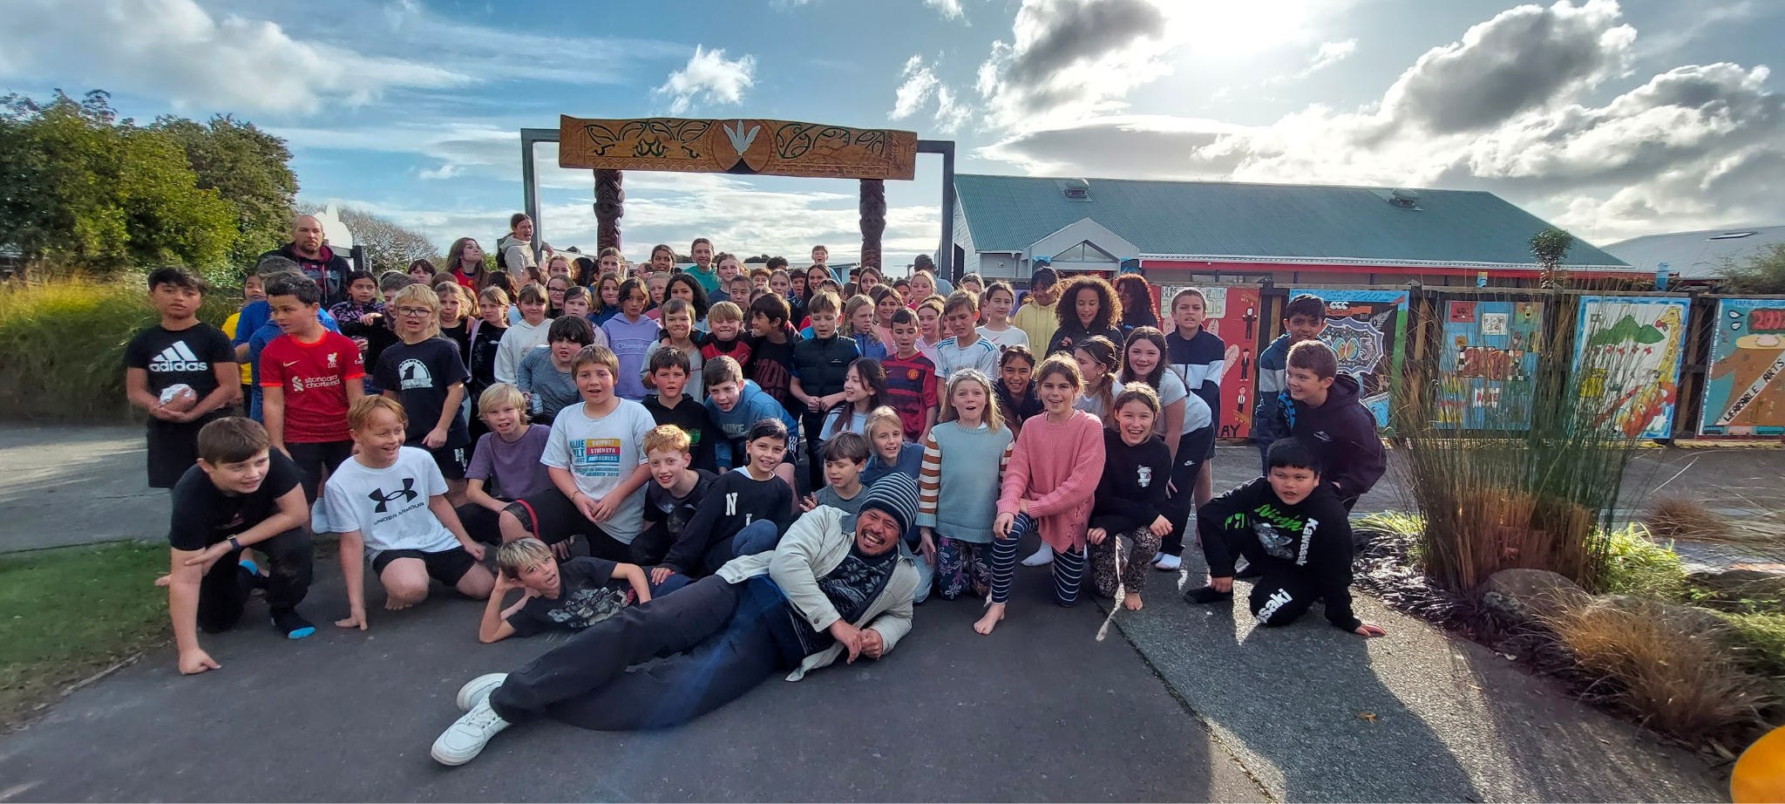

Information Book 2024

Kapakapanui School 23 Rimu Street, Waikanae
Phone: (04) 902 5015 Email: admin@kks.school.nz
Web: www.kapakapanui.school.nz

WELCOME TO KAPAKAPANUI SCHOOL

Welcome

Rau rangitira ma, tena koutou katoa
He pōwhiri tenei ki nga iwi katoa
O te kura tuarua o Kapakapanui

A very warm welcome to Kapakapanui School. We look forward to meeting you and working with your children on their journey through our school. — Noho ora mai

Ngā mihi
Craig Vidulich
PRINCIPAL

VISION
Rise and Shine – Maranga a Whiti
For all our students to rise to the challenge of learning and shine brightly every day during their learning journey at Kapakapanui School.
We want -
To develop young people who will be confident, connected, actively involved, lifelong learners.
'Students who actively seek, use, and create knowledge'

Te Ara Student Pathway
Our school has 6 values that make up our Te Ara student pathway for each syndicate of the school. These values are the key capabilities that we want our students to develop and learn for today and for the future.

Whakaaro- To think, plan, consider
Kotahitanga - Unity and togetherness
Manawanui - Perseverance, determination, persistence, resilient, strong and brave
Kaitiakitanga - Guardianship, stewardship, trusteeship, trustee
Whānaungatanga - Relationships, kinship, sense of family connection
Manaakitanga - Kindness, generosity, support

Each pathway builds on the skills required for each value as students journey through our school from Years 1- 8. Each term the whole school also focuses on one value through a school wide theme.

SCHOOL ORGANISATION

WHĀNAU
Our school is divided into five whānau, each made up of different class levels. This system helps promote the caring, family atmosphere we try to foster at our school. Your child will stay in the same whānau while at Kapakapanui, and if you have more than one child at school, they will be in the same whānau.

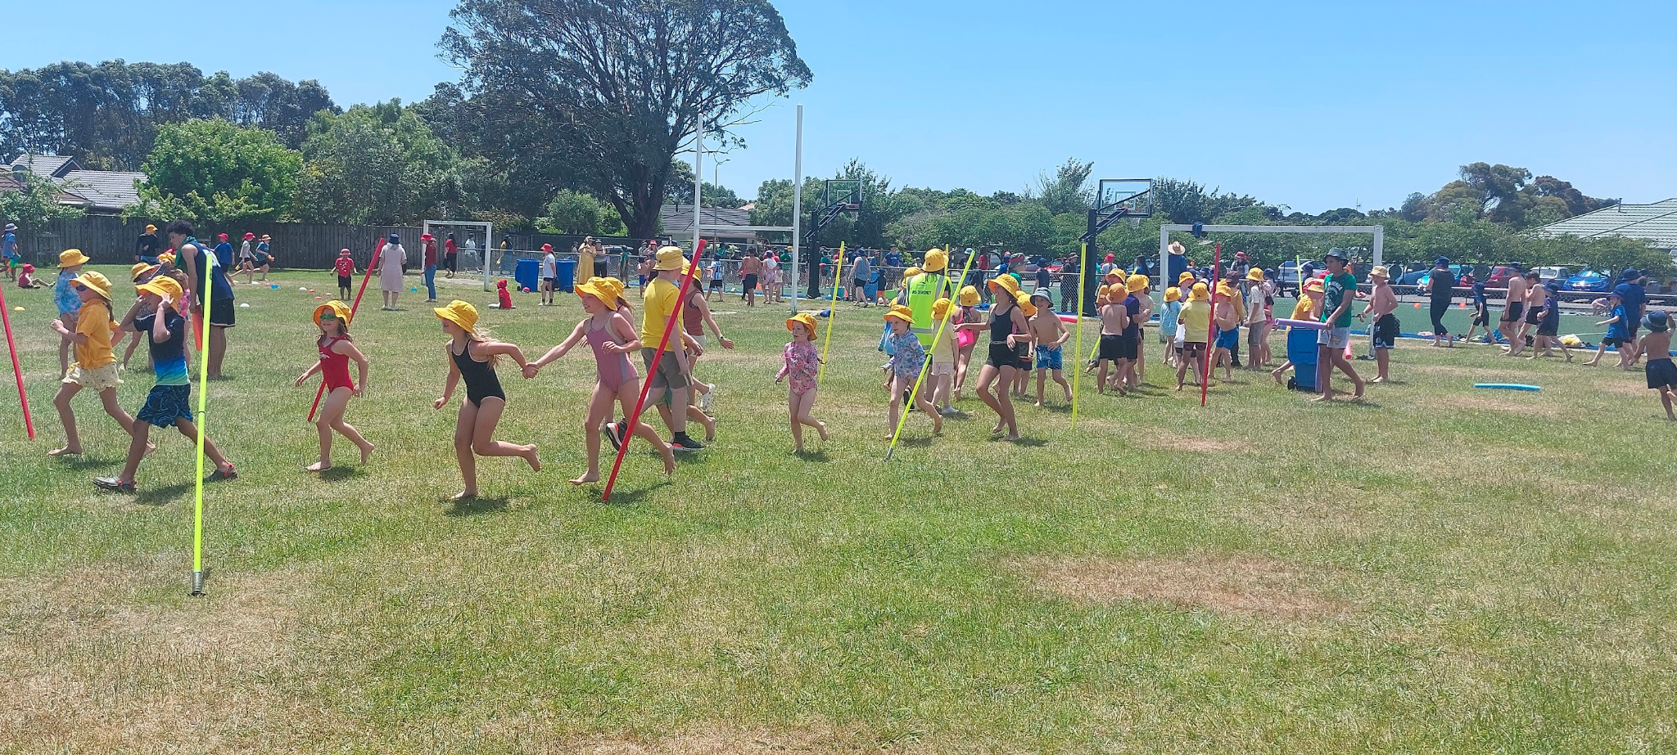

Our whānau names represent our school, community and the local environment.
- Te Whenua (land). Green hats
- Te Moana (sea). Light blue hats
- Te Awa (river). Navy blue hats
- Te Waka (canoe). Red hats
- Ngā Manu (birds). Yellow hats

Each Thursday at 12-12.45pm we have our Whānau time. During Whānau time, children will take part in a variety of activities in their buddy groups. This is followed by Whānau lunch. This is a chance for buddy groups to have lunch together. Each Term whānau teams compete to gain points that go towards winning the ‘Whānau Shield’.

Each Whānau is led by a team of Year 8 leaders who are involved in planning, leading and implementing ideas and events.

SYNDICATES

The other organisation is called the Syndicate. This relates to the year of schooling. We have four syndicates this year:

Nga Kākano | Nga Kaitoro | Ngā Kaipātai | Rangatahi
Yrs 0-2 | Yrs 3-4 | Yrs 5-6 | Yrs 7-8

STAFF LOCATIONS 2024

Craig Vidulich | Principal | Admin Block
Rochelle McKenzie | Associate Principal | Admin Block
Michelle Whitaker | Associate Principal | Admin Block
 | NGĀ KĀKANO
Katy Harris | Syndicate Leader/Kauri Pod | Room 18
Cheryl Edwards | Kohekohe Pod | Room 14
Annie Christie/Rose Graham | Kohekohe Pod | Room 15
Mark Wright | Rimu Pod | Room 16
Natalie D'Cunha | Rimu Pod | Room 17
Selena Irving | Kahikatea Pod | Room 13
Sarah Wild/Amy Burgess | Kauri Pod | Room 19
Rachel Jackson | Kahikatea Pod | Room 19
 | NGĀ KAITORO
Brenda Nelson | Syndicate Leader/Nīkau Pod | Room 20
Becky Dewdney | Nīkau Pod | Room 21
Sue Lemmon | Karaka Pod | Room 22
Neil Milmine | Karaka Pod | Room 23
Lucy Tristram/Maria Cassidy | Nīkau Pod | Room 24
 | NGĀ KĀIPĀTAI
Kerri Davey | Syndicate Leader/Rātā Pod | Room 4
Paula Medrano Durban | Rātā Pod | Room 3
Emma Swanson | Kōwhai Pod | Room 2
Shelly Torr | Kōwhai Pod | Room 1
 | RANGATAHI
Lynnie Gilmore | Syndicate Leader/Mānuka Pod | Room 10
Diane Richards/Sophie Jones | Mānuka Pod | Room 9
Matt Wynne | Pukatea Pod | Room 11
Kerryann Holwill | Pukatea Pod | Room 12
Fiona Howard | Tōtara | Room 8
Alison Roberts | Children with Special Abilities | SENCO

 | TEACHER AIDES
Barbara Higgott | Thea van der Meulen | Rosie Va’a
Louise Reilly | Ngatai Derbidge (Kaiārahi) | Carol Coulthard
 | Lesley Millns | Carol McCaffrey
Charlotte Arthurs | Dana Reynolds | Michelle Moir
 | ANCILLARY STAFF
 | Executive Assistant | Admin Block
Lisanne Templer | Office Assistant | Admin Block
Natasha Milmine | Library
Adrian Whiteman |  | Caretaking/Grounds

KAPAKAPANUI SCHOOL LOGO

Ko Kapakapanui Te Maunga

The school logo is a stylised view of the mountain Kapakapanui. Kapakapanui is the dominant maunga/mountain of the area.

The Sun – Rise and Shine – Maranga a Whiti

The rising sun is included in the design to symbolise the beginning of a journey, a learning journey for students. It is used to denote warmth and enlightenment as our students discover new knowledge about themselves and their world. The sun also shines brightly to draw a comparison to our students who we also hope will shine in their achievements and endeavours while at Kapakapanui School.

The Poutama Tukutuku Pattern

The Poutama design in ancient Maori lore symbolised a climb made by the folk hero Tawhaki to receive the three baskets of knowledge from the gods.

In our logo this is also used to symbolise learning and the gaining of knowledge. When we look at the construction of the poutama, we find a series of steps denoting the steps of progress and advancement. Briefly, these are education and the striving for betterment, the planning of a child's future… by parents, family and iwi.

SCHOOL TIMES
9.00am. School starts.
11.00an Morning break
11:20am End of morning tea.
12.45pm Lunch
12:55pm End of 10 minute lunch eating.
1:40pm Lunch ends.
1:45pm Ready to start learning.
2:50pm Pack up time.
3.00pm School finishes.
3:10pm Bus bell.

SCHOOL TERMS AND HOLIDAYS 2024
Term One Wednesday 7th February to Friday 12th April
Term Two Monday 29th April to Friday 28th June
Term Three Monday 22nd July to Friday 27th September
Term Four Monday 14th October to Friday 20th December. Other public holidays are as follows:

Public Holidays

Waitangi Day Tuesday 6th February
Good Friday Friday 29th March
Easter Monday Monday 1st April
ANZAC Day Thursday 25th April
King’s Birthday Monday 3rd June
Matariki Friday 28th June
Labour Day Monday 28th October
Christmas Day 25th December
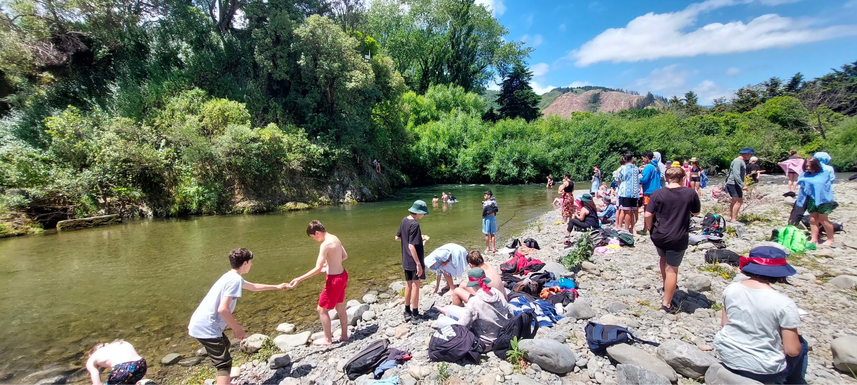
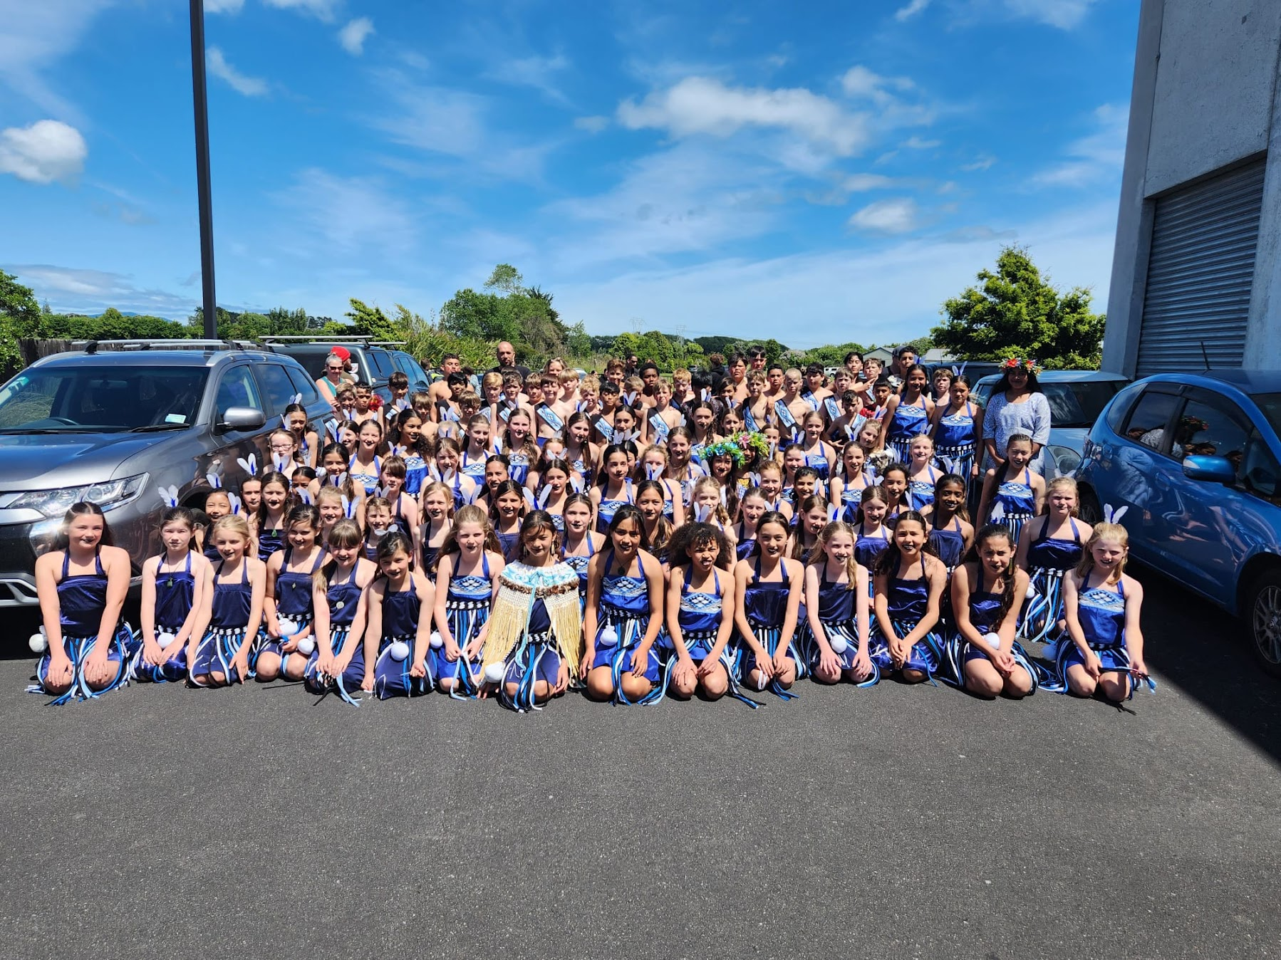
THE A-Z OF KAPAKAPANUI SCHOOL

ABSENCES
Please inform the school office if your child is going to be absent from school. You can leave a message on the ‘Absence Line’ or send a message through our school app. You will need to contact the school office to get a login for the app. Unexplained absences will be followed up by texting the main caregiver.

ALLERGIES
Kapakapanui School aims to provide a safe environment for students and staff with allergies by identifying and minimising risk, being prepared, and raising awareness. Allergies are common and can result in a range of reactions from mild to life-threatening. Examples include hay fever, asthma, bee stings, and skin reactions, as well as allergies to specific foods or medicines. We support students with allergies to participate in the same educational and recreational activities as their peers. Please advise the school, at enrolment or any time afterwards, if their child has any known allergies.

ASSESSMENT AND REPORTING
Student-led conferences take place during terms 2 and term 4. Students also receive their Mid and End of year reports at this time. During the year students will also be sharing their learning and work through Seesaw on a regular basis.

AUDIO VISUAL TESTING
An audio visual tester from the Public Health Service checks new entrants’ sight and hearing. Children are checked again in year 7.

BUS SERVICE
Children will be picked up from the bus stop nearest their home as usual and be brought to the school gate. There will be no restriction on age, since this is a pay service. The return bus leaves school at 3.15pm and returns children to their bus stop.

CELLPHONES
If you require your child to have a cellphone for after school messages, it must remain in the child’s bag and not be used at school. The school takes no responsibility for the loss or damage of any cell phones at school. Please do not contact children during school time using personal devices e.g. cellphone, email or smart watches. Rather contact the office if you would like a message passed to your child.

COMMUNICATION
Teachers or syndicates will send home a newsletter once a term to keep parents posted as to school happenings and curriculum focus as well as regular emails during the term from class teachers.

If you have a concern related to a school matter please approach the class teacher in the first instance and the Syndicate Leader, Associate Principals or Principal if you are still not satisfied.
A copy of our complaints procedure is available.

CURRICULUM

Our school follows the guidelines of the New Zealand National Curriculum. We have developed a school wide local curriculum based on this that is responsive to the needs of our learners. This includes school wide themes each term based on our school values.
Click here to view our 2024 Local curriculum, or view this on our website under the 'Parent Information' tab.
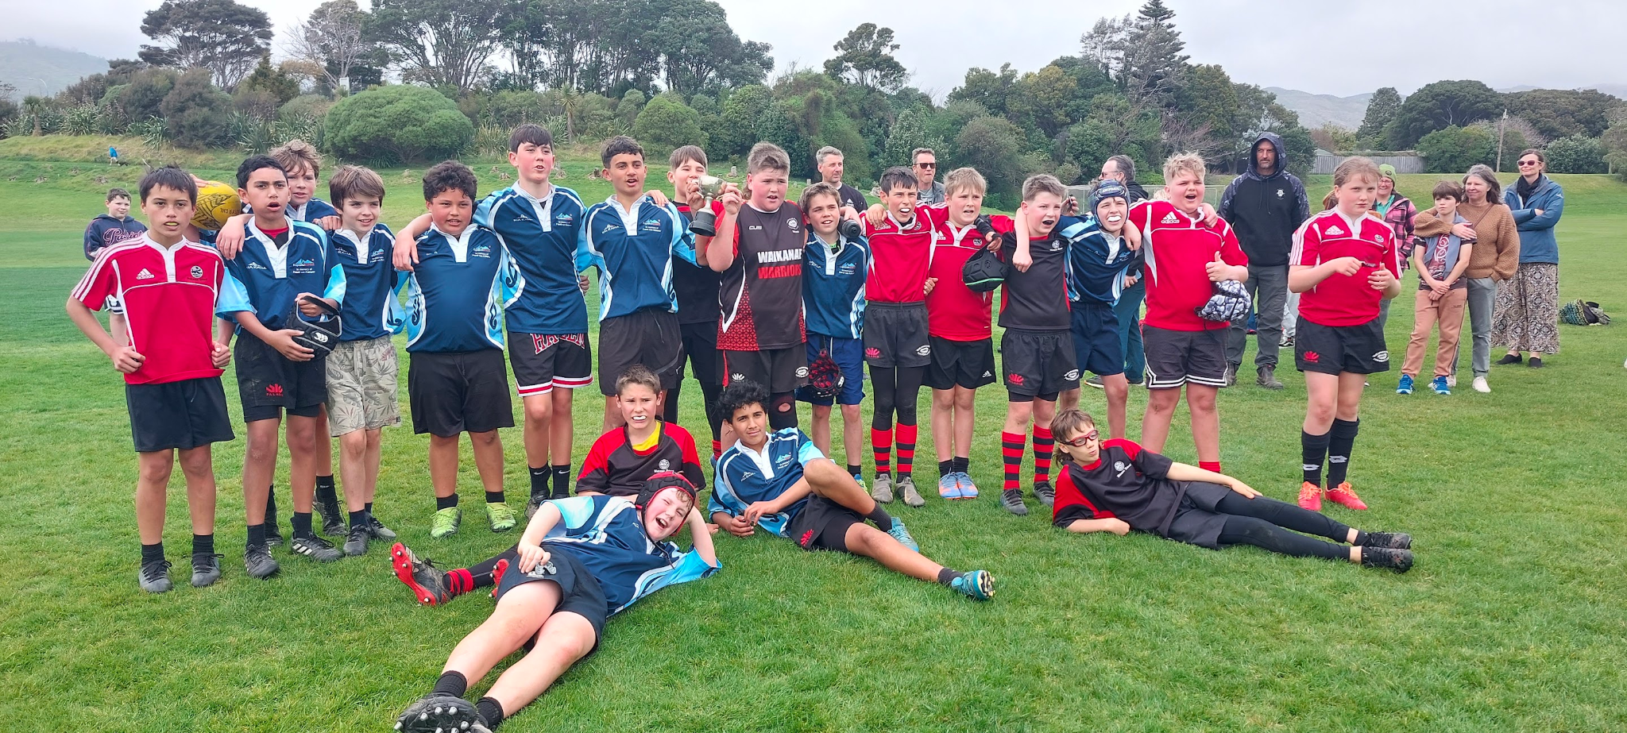

COMPUTERS
BYOD – Bring your own device. Children in Years 5-8 can bring a Chromebook for use at school. Chromebooks range in price from $350-$400 and can be purchased from the usual AV shops.
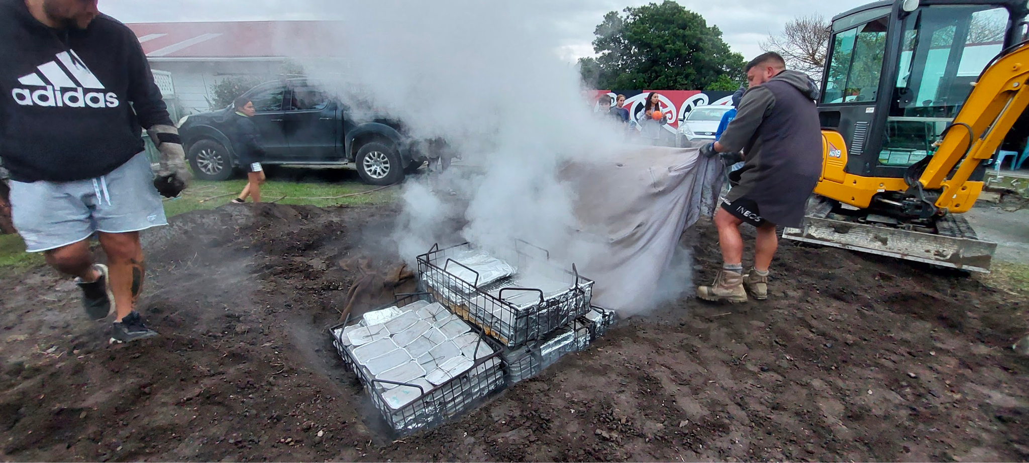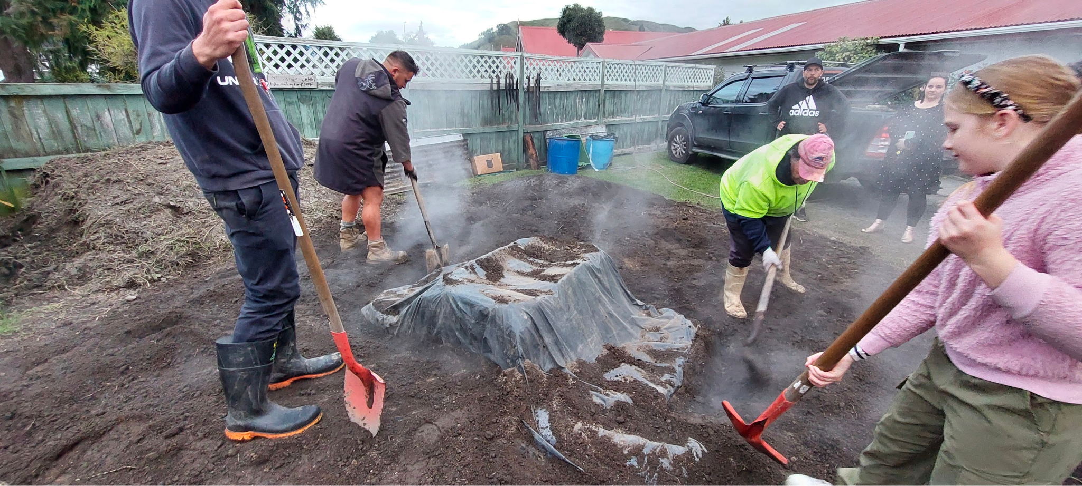

Classroom Computers
Each class has computers which are used as learning tools to assist with learning and teaching.

The school has a Digital Citizenship/BYOD agreement to ensure responsible and safe use of computers at Kapakapanui school. Additional information can be found on our website-click here

DENTAL CARE
Students needing dental treatment will be seen at a hub at Paraparaumu School. If you would like more information, you can call 0800 TALK TEETH.

MOE DONATION SCHEME
Kapakapanui School has signed up to the Ministry of Education Donations Scheme. This means that there are NO school donations for families to pay. We received $154.13 per pupil in our Operations Grant which covers many of the usual school related costs. Please note that sports fees, band fees and school camps do not qualify for the donations scheme and payments for these are still required.

DRINK
We encourage children to have their own water bottle, which is kept in the classroom and saves children leaving the classroom when they are thirsty. Please do not send fizzy or sports drinks to school. There are water fountains around the school playground.

FACEBOOK/INSTAGRAM – SOCIAL MEDIA
Please inform the office if you do not want your child’s photo to be on the school Facebook/Instagram page. Please note we do not publish full names or room numbers.

FIRST AID AT SCHOOL
When a child becomes unwell or is injured at school, we attend to the immediate needs and then, if necessary, get in touch with parents. If the child needs a Doctor, we do our best to contact the parent, but failing this, we will take the child to the Medical Centre ourselves and try again to contact the parent. Please keep children at home until they are FULLY recovered from any illness. Their wish to return should not override complete recovery from sickness.

GYM FUN
All syndicates will undertake a number of gymnastic sessions run by the Waikanae Gym Club. Parents are requested to volunteer to provide transport. The cost for the tuition and use of the gym club is part of the school donation. Year Ones will take part in PMP, in the School Hall, this is generally 3 mornings per week. Appropriate clothing must be worn for these sessions, including no zips, skirts for girls and hair tied back.

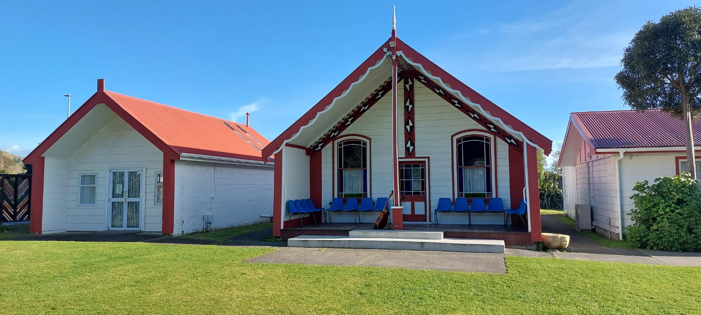

HALL
Bookings for the school hall may be made by telephoning the school office.

HUI
This is held once a week on a Tuesday morning as a short time to connect as a school to share notices, information and welcome new students.

INTER-SCHOOL SPORTS
As part of the Kapiti District's Sports Association, some of our children represent Kapakapanui in the following events:
Swimming, Senior & Junior Winter Tournament, Cross Country, Softball, Tennis
Orienteering, Volleyball, Athletics, Triathlon, Softball, Rugby, Soccer, Golf, Cricket, Indoor Basketball.
Netball, Hockey and Touch are other sports played after school or on the weekends

JEWELLERY
We prefer students not to wear jewellery at school. However, ear studs and simple necklaces are allowed. Nose studs and other visible piercing are not allowed.

KINDO
KINDO register to register. This is a useful app to download. It makes paying for and keeping track of any school expenses very simple.

LIBRARY
We have a well resourced library which is open from 8.45am-3.15pm each day, including lunchtimes Mon-Thurs. Most classes visit the library weekly to issue/return books, learn information literacy skills, and gain exposure to the latest books in children’s literature. Our full time librarian is also available to provide assistance to parents about books for their children.

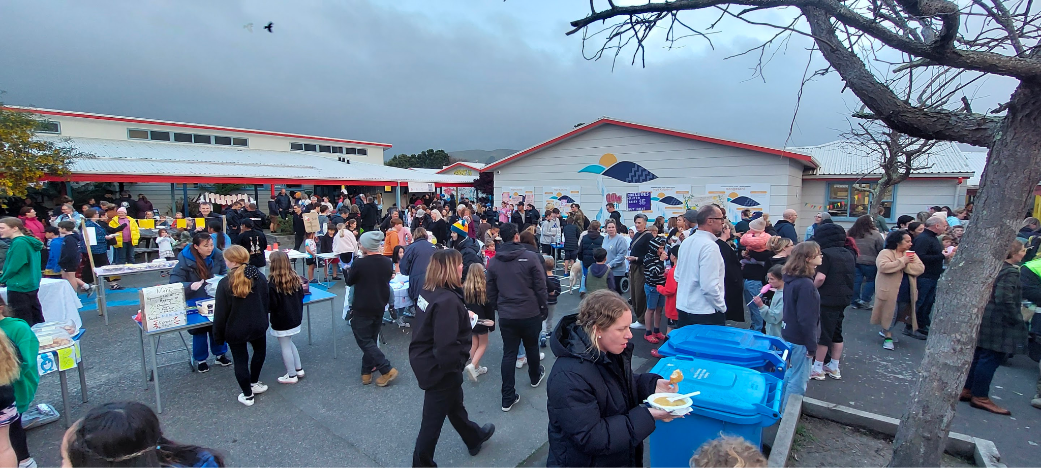

LOST PROPERTY
Property which is left around the school is put on display outside Room 7. Any property which is named is returned. We would like to see all property named to ensure it can be returned.

MAINSTREAMING
It is necessary to make an appointment in advance if you have a child with special needs. In most cases we will plan a gradual transition to school. This is to ensure that the necessary support systems and resources are available. A case conference is usually held to discuss placement issues.

MEDIATORS
A group of Year 8 children is selected and trained to mediate in the small issues that happen in the playground. Any problem too big is directed to a duty teacher or brought to the classroom teacher or Associate Principal to sort out once school has resumed. Mediators meet with our Associate Principals regularly to discuss problem areas in the playground. Values Awards are awarded by mediators at each assembly. Mediators can be identified by the red band they wear around their hats and T-Shirts. During break times they are situated at desks near the playground and field areas.

MUSIC
We have a range of music options available to children.
Guitar and drumming lessons are available during school hours. Tutor: House of Sound
Keyboard lessons are available during school hours. Tutor: Louise Aitken and Malu Jonas.
The School Band meets once a week and performs once a term. Tutors: Neil Milmine and Anje Glindamann
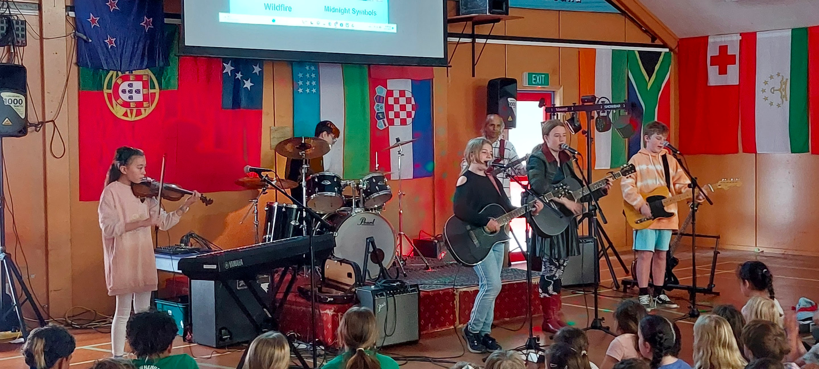

NEW ENTRANTS
We run a transition to school programme. Please see “Kickstart Programme” on the back page of this booklet. Children and families are also encouraged to make visits to their new classes.

NEWSLETTERS
Newsletters from the Principal and Staff, aimed at keeping parents fully informed, are emailed each Tuesday. The newsletter can be accessed via the school website.

PARENT PORTAL-SCHOOL APP
The eTAP parent portal is your window into your child's school. The portal gives you access to report an absence, print off your end of year tax receipt, view the school calendar and many other helpful tools. When your child first commences, the school office will email you a link with login details. They are also able to reset your login if needed at a later date. Please download the eTAP app

PARENT TRANSPORT
From time to time we find it necessary to call upon parents with cars to help transport children. We appreciate the excellent support given by the parents at Kapakapanui in this regard. All children must be seated with a seat belt on any outing. Cars used for transport must be registered with a current W.O.F. and all drivers must have a current full licence. Please do not smoke, vape or use a cell phone while transporting children. Children up to the age of 7 must have a booster seat, these are available from school.

PHOTOGRAPHS (SCHOOL)
A photographer will be at the school to take class photographs and individual photographs, at some time during the year. All children are photographed and order forms are sent home for families to purchase photo packs if they wish.

PRESCRIPTION & NON-PRESCRIPTION MEDICATION
Our School Policy is that students are not permitted to carry prescription or non-prescription medicines in their bags for self-administration without the schools expressed permission. Arrangements for administering short-term prescription medicines are the responsibility of the
Caregivers. Decisions on administering long-term medicines by staff at the school will be made by the Principal on a case-by-case basis. (Ask to see the full policy if needed).

PUNCTUALITY
Children are expected to be at school by 9am. An email admin_2@kks.school.nz is required if your child is to be late or absent. We recommend you download the FREE school app which is available through Google and the App store. This is a great way to communicate your child’s absence, receive notifications, access school notices and send digital permission for trips etc. If we do not hear from you by 9.30am the office staff will send out a text to check on your child’s whereabouts. It is important to notify office staff as well as class teacher of any absences.

New five year olds stay until 3pm from Day One. An early finish can be arranged if you are concerned that your child is getting too tired.

RESOURCE TEACHERS LEARNING & BEHAVIOUR (RTLB)
This support facility is set up to provide assistance to students, teachers and parents in the development and maintenance of appropriate social and learning behaviours. There are several Resource Teachers Learning & Behaviour covering the Otaki Kapiti region. Referrals are made through the class teacher in collaboration with our SENCO (Special Education needs coordinator).

RESTORATIVE PRACTICE
Quality teaching is integral to effective management of student learning and behaviour. Building positive constructive relationships with learners is a key competency for teachers. Kapakapanui School believes in strong, positive constructive relationships to enable all to achieve maximum potential and growth.

To ensure we have effective conditions for learning and teaching, Kapakapanui School utilises a variety of strategies and programmes to foster a co-operative school ethos. Integral to this is a supportive behaviour management programme. At Kapakapanui School we work on the restorative principles of behaviour management. The programme promotes the well-being of all
those involved in the school community. Through this programme, students in particular, learn skills to manage their own behaviour and resolve conflict through mutual respect and co-operation.

The key facets of behaviour management will include:
- prevent and minimise
- encourage and correct
- apply appropriate consequences
- repair and rebuild

These will promote:
- ownership of behaviour
- respecting mutual rights
- integrating teaching and learning
- building self-esteem
- building positive relationships

ROAD PATROL
We have a school-patrolled pedestrian crossing outside the school at the Rimu Street and Belvedere Ave entrances. N.B. The dotted yellow line on the road at the school entrance indicates a NO STOPPING ZONE; therefore, please do not park within the zones. It is very difficult for our school patrol wardens to see approaching vehicles, especially when cars stop within these zones. Both school driveways are off limits, except for staff cars and couriers. To overcome the problem of reversing cars putting children at risk - particularly on wet days. Please drop off and pick-up children at the Roadside, not in the school entrance or car park.

We need some parent volunteers to supervise the school crossing from 8.30am to 9:00 am and 3.00pm to 3.15pm as these times of the day are very busy for teachers and the Principal. If you can help by supervising a morning or afternoon once a week please give your name to Diane Richards, Teacher in Charge of Patrol.

SCHOOL HATS
All children are expected to purchase and wear their own school hat. The cost to purchase a hat is $18. School hats are available from the school office and KINDO. Hats are issued in the colour of the Whānau group that the child is part of.
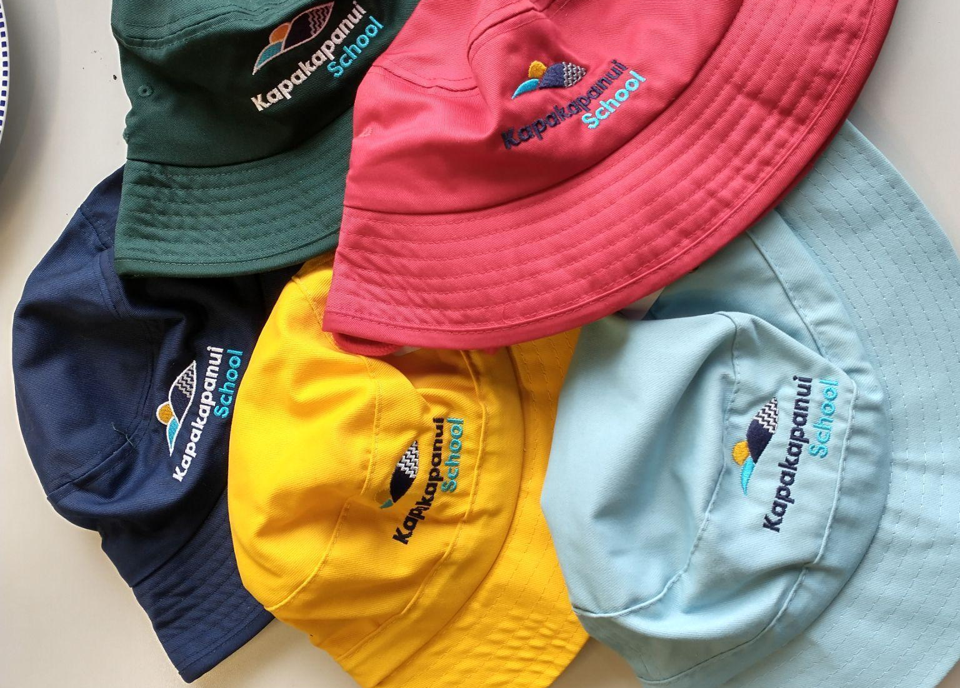

SCHOOL HOODIES
Available to purchase from the school office/KINDO. Orders sent off twice a term, cost of Hoodie $50. Sizes available to try at the office.

SCHOOL LUNCHES
Children are supervised by class teachers between 12.45pm and 12.55pm. We encourage children to take home uneaten items so you are aware of how much they need.

We encourage you to provide healthy snacks and lunches for your children and ask you to use reusable containers, not plastic wrap. No sweets, candy bars or fizzy drinks.

SHADY SCHOOL PROCEDURE
Kapakapanui is a Sun Safe School. Children are required to wear school hats in Term One and Term Four. Crop tops and singlet tops are not to be worn at school as covering up is the safest protection from the sun. The Shady School policy will be reinforced in a positive way through the newsletter.

SPEECH THERAPIST
A Speech Therapist can be called in if required. Application to the Special Education Service through the class teacher is the protocol.

SPORTS AND CULTURAL GROUP UNIFORMS
The recognised sports uniform for our children to take part in Inter-school Sports or Sports Days are the official Kapakapanui School tops. Uniform tops are distributed through the school library and must be returned on the same day.

SWIMMING SESSIONS
All children are expected to participate. We use the Waikanae Pool. At times we are able to access qualified swimming tutors during the season. Syndicates will send out notices notifying you of the swimming days for your child.

COLLECTING CHILDREN FROM SCHOOL
If it is necessary to collect children from school during the school day, please call the office. Children must be signed out if they leave prior to the end of the school day or if they go home for lunch.

TECHNOLOGY FOR YEAR 7/8 STUDENTS
Our senior students travel to Otaki College to work in technology classes such as cooking, woodwork, digital technology etc. Three classes will go from 8:30 am and the other three at 10:00am. Groups will be smaller, less time but a higher quality programme will be offered. We travel to the Technology Centre at Otaki College.

TRIPS AND VISITS (EOTC)
School policy encourages visits to a wide variety of places of educational interest. For the older children this could be a couple of nights or a week. Information about these events will be sent from the class teacher via emails or google forms. In the case of overnight trips, approval will have been gained from the Board of Trustees. For the longer trips children may be involved in some fundraising. Costs to parents are always considered carefully in planning trips. Written parental permission is requested at enrolment to cover visits within the local community. Further permission will be gained by the class teacher for travel beyond this.

VISITORS TO SCHOOL
Visitors to school are always welcome. When visiting, please make the office your first calling point to sign in. Visitors also need to sign out before they leave. Remember also that during class time it is not possible to discuss individual learning programmes and progress. An appointment for such discussion should be made by ringing the Principal or office staff.

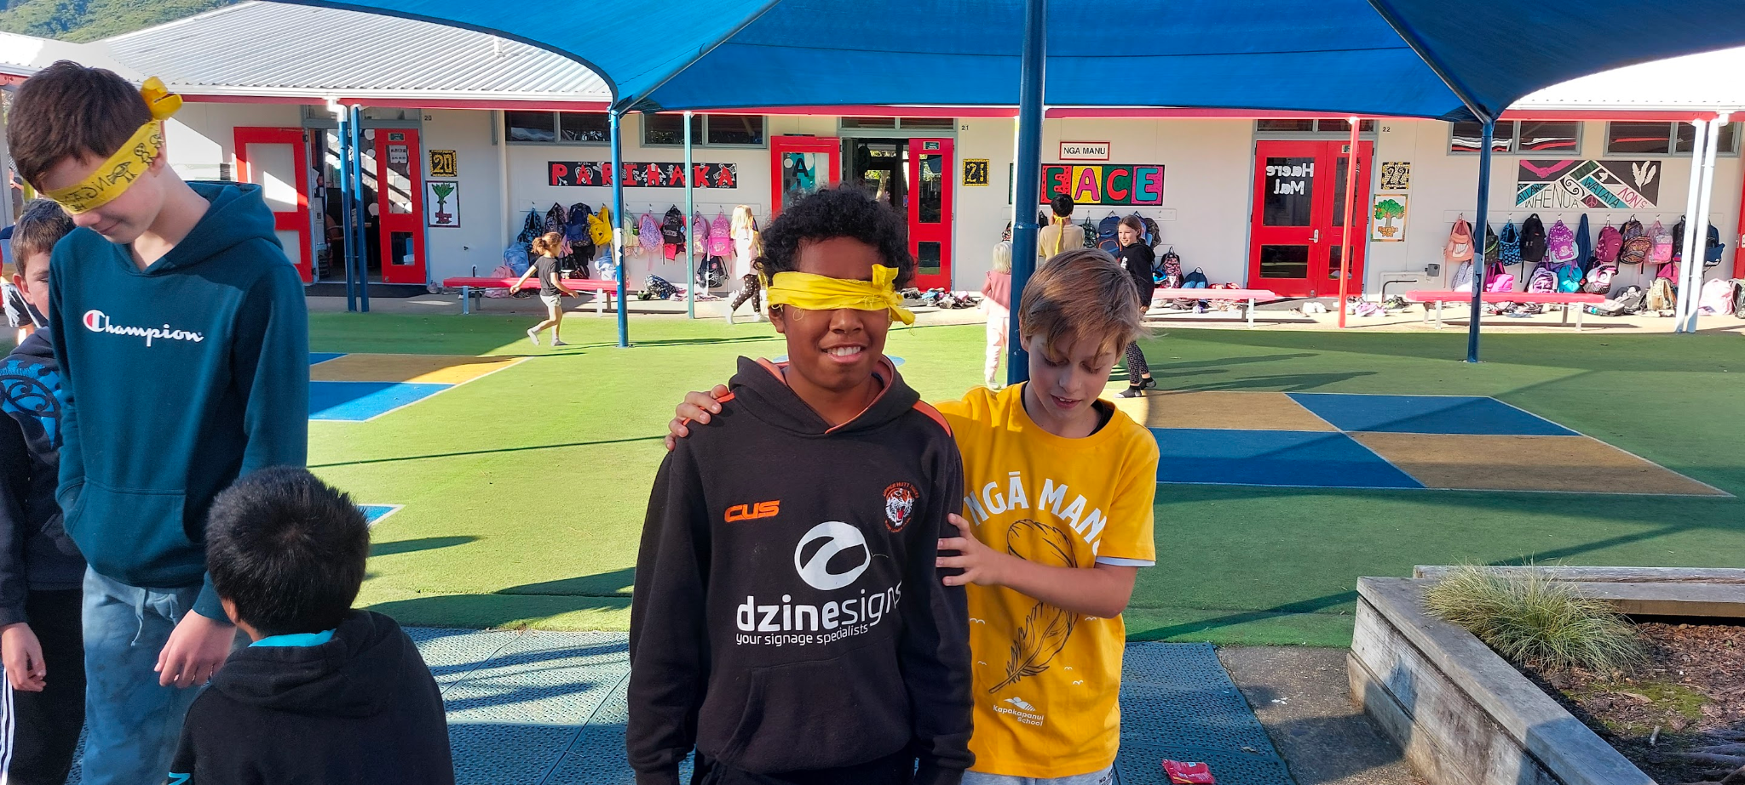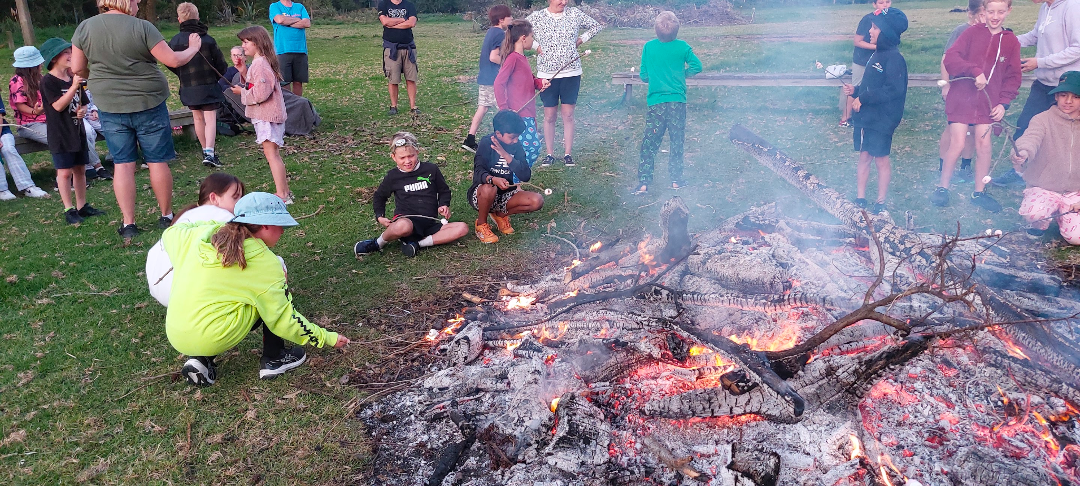

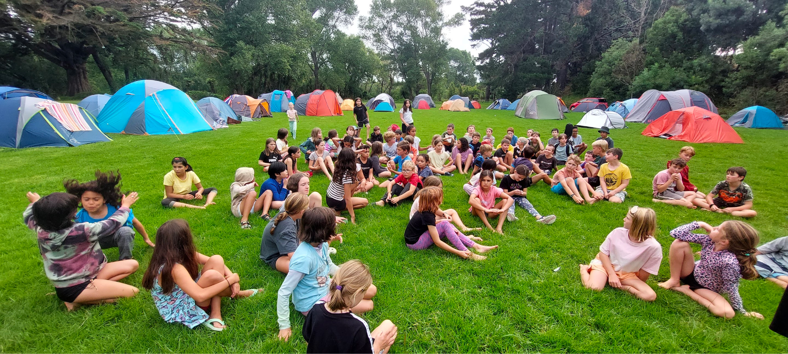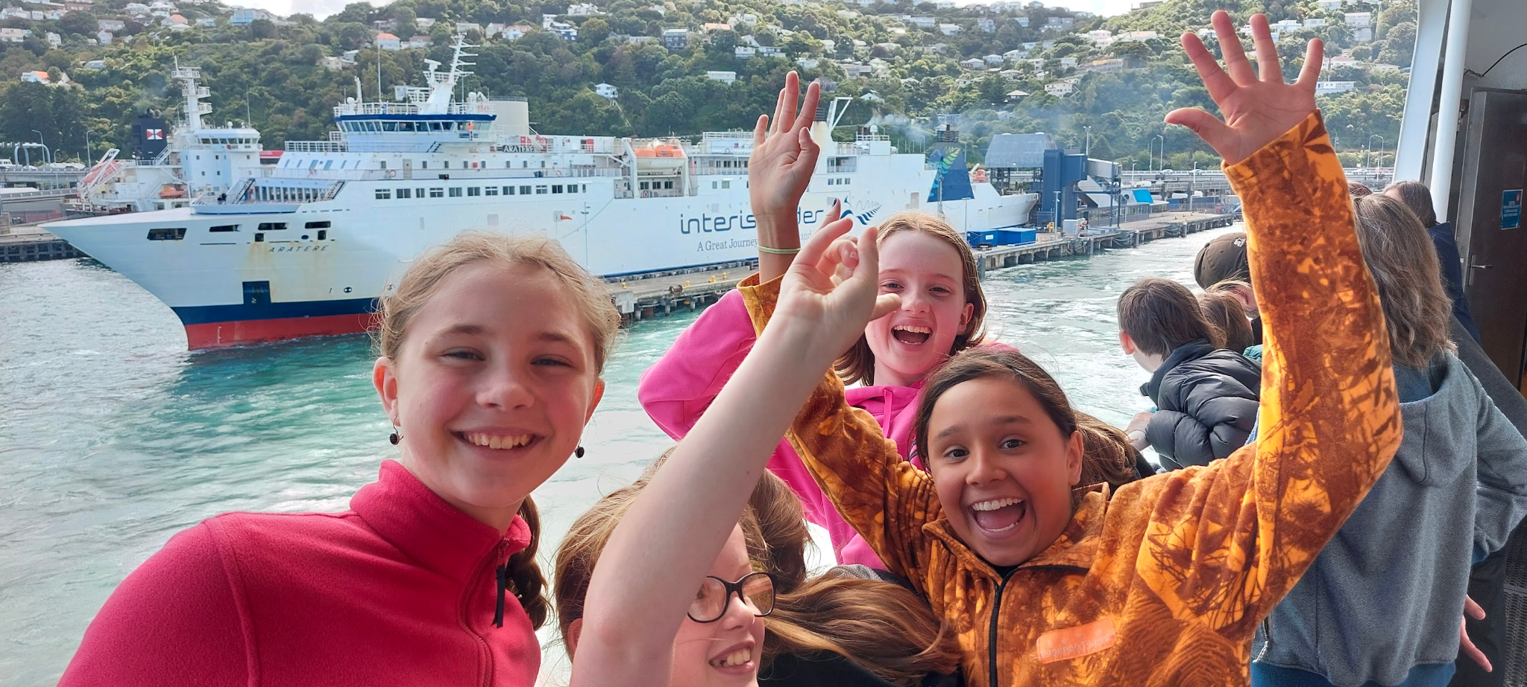

KICKSTART TO SCHOOL
This is our transition to school programme which is suitable for all children turning 5 that are enrolled at Kapakapanui School – along with their parents or caregivers.

WHEN: Every Monday during term from 1.50pm – 2.50 pm
WHERE: Room 7

You are welcome to come along for about a term before starting school.

Come and make new friends, meet some of the staff and try some of the things we do at school

Enquiries: Email: michelle.whitaker@kks.school.nz

