KAPANUI SCHOOL ANALYSIS OF VARIANCE – FOR THE YEAR ENDING 31 DECEMBER 2011
STUDENT ACHIEVEMENT GOALS 2011
Strategic Goals
- To Improve Literacy and Numeracy - Foundation Skills / to improve student achievement through evidence based teaching and specific achievement targets (2.3.3 – Kapanui School Charter Page 13)
- Students Goals - Using languages, symbols and text (Kapanui School Charter Page 8)
- When students leave from Kapanui School we would like them to ......
  - Have developed basic understandings, knowledge and skills across the essential learning areas.
  - Communicate competently and confidently by listening, speaking, writing and reading
- We want all students are able to access The New Zealand Curriculum as evidenced by achievement in relation to National Standards. (Kapanui School Annual Plan 2011)
Annual Aim - To increase the number of students achieving at or above the National Standard for reading, writing and mathematics
In November each year students in Y4-8 will be assessed against the National Standards. Students at Y1-3 will be assessed against the national Standard at the end of 1 year, 2 years and 3 years at school related to them. Teachers will assess against the standards using an overall teacher judgement. An OTJ involves drawing on and applying the evidence gathered up to a particular point in time in order to make an overall judgement about a student’s progress and achievement.

Annual Goals | Responsible | Historic Position – Position T4, 2010 | Achievement Targets Nov 2011
1.1 – To increase the number of students achieving at or above the National Standard for reading  Overall increase 3.5% | Principal |  | Overall teacher judgements based of available assessment information will show 90% Y1- 4 and 80% Y5-8 students reading at or above the expected MOE National Standard  Target achieved - 2011 T4 Average for Y1-4, 89.1% (-0.9) - 2010 89.8%  Target not achieved- 2011 T4 Average for Y5-8, 78.7% (-1.3%) – 2010 71%
  National Standards T4
  Year | Reading %
   | 2010 | 2011 | 2010 | 2011 | 2010 | 2011 | 2010 | 2011 | 2010 | 2011
   | Above |  | At |  | Below |  | Well Below |  | At +
  1 | 47.9 | 67.2 | 33.3 | 19 | 16.7 | 0 | 2.1 | 0 | 81.2 | 86.2
  2 | 66.2 | 62.1 | 28.2 | 36.2 | 2.8 | 13.8 | 2.8 | 1.7 | 94.4 | 98.3
  3 | 25.4 | 43.9 | 69.5 | 43.9 | 3.4 | 8 | 1.7 | 3.5 | 94.9 | 87.8
  4 | 30.6 | 34.9 | 58.1 | 49.2 | 9.7 | 11.1 | 1.6 | 4.8 | 88.7 | 84.1
  5 | 30.8 | 29 | 34.6 | 53.2 | 32.1 | 12.9 | 11.5 | 4.8 | 65.4 | 82.2
  6 | 26.6 | 41.8 | 48.4 | 34.5 | 21.9 | 16.4 | 3.1 | 7.3 | 75 | 76.3
  7 | 42.3 | 25.4 | 30.8 | 44.8 | 21.2 | 19.4 | 5.8 | 10.4 | 73.1 | 70.2
  8 | 21.6 | 27.5 | 49 | 58.8 | 17.6 | 13.7 | 11.8 | 0 | 70.6 | 86.3
   | 36.4 | 41.5 | 44.0 | 42.5 | 15.7 | 11.9 | 5.1 | 4.1 | 80.4 | 83.9
1.2 – 80% Y5-8 students spelling at or above chronological age (Nov) | Principal | Peters spelling ages indicate that students are not meeting the Kapanui expectation of 80% Spelling age at or above their actual age.  See chart below – spelling ages continue to show a significant percentage of students with spelling age test results below their chronological age. Results of the three year focus on reading indicate a significant rise in reading ages. A similar focus on spelling should be considered in 2012. This focus should be within an overall focus on the teaching of written language.  Spelling Recommendations 2012 –  - Spelling teaching strategies to be part of the 2012 improving the quality of written language staff development focus.  - A metacognitive, problem solving approach that helps students self monitor their learning, to think and talk about learning and what they know should be developed.  - That teachers place less emphasis on spelling lists and more on developing student understanding of orthography (how letters combine to represent sounds and form words), phonology(how sounds are organized and used in natural languages), and morphology (the study of morphemes - words, word stems, and affixes)  - That explicit links are made between what is taught and the spelling knowledge that students bring to their writing. | Evaluation of Nov Peters Spelling age results will show 80%+ students spelling at or above chronological age  Target not achieved
1.3 – To increase the number of students achieving at or above the National Standard for writing  Overall decrease 0.77% | Principal |  | Overall teacher judgements based of available assessment information will show 90% Y1- 4 and 75% Y5-8 students writing at or above the expected MOE National Standard  Target not achieved - 2011 T4 Average for Y1-4, 84.5% (-5.5) - 2010 %  Target not achieved - 2011 T4 Average for Y5-8, 73.4% (-1.6%) – 2010 %
  Year | Writing %
   | 2010 | 2011 | 2010 | 2011 | 2010 | 2011 | 2010 | 2011 | 2010 | 2011
   | Above |  | At |  | Below |  | Well Below |  | At +
  1 | 16.7 | 3.4 | 64.6 | 81 | 18.8 | 12.1 | 0 | 3.4 | 81.3 | 84.4
  2 | 13 | 15.5 | 73.9 | 65.1 | 11.6 | 19 | 1.4 | 0 | 86.9 | 80.6
  3 | 5.1 | 8.8 | 81.4 | 73.7 | 11.9 | 14 | 1.7 | 3.5 | 86.5 | 82.5
  4 | 27.4 | 28.6 | 66.1 | 49.2 | 6.5 | 19 | 0 | 3.2 | 93.5 | 77.8
  5 | 32 | 21.3 | 42 | 65.6 | 26 | 13.1 | 0 | 0 | 74 | 86.9
  6 | 17.2 | 21.8 | 48.4 | 43.6 | 26.6 | 25.5 | 7.8 | 9.1 | 65.6 | 65.4
  7 | 9.6 | 11.9 | 51.9 | 35.8 | 30.8 | 37.3 | 7.7 | 14.9 | 61.5 | 64.2
  8 | 5.9 | 13.7 | 49 | 58.8 | 29.4 | 21.6 | 15.7 | 5.9 | 54.9 | 72.5
   | 15.9 | 15.6 | 59.7 | 59.1 | 20.2 | 20.2 | 4.3 | 5.0 | 75.5 | 74.73
1.4 – To increase the number of students achieving at or above the National Standard for mathematics  Overall increase of 5.7% | Principal |  | Overall teacher judgements based of available assessment information will show 90% Y1- 4 and 75% Y5-8 students at or above the expected mathematics MOE National Standard  Target not achieved - 2011 T4 Average for Y1-4 85.9% (-4.1%)  Target not achieved - 2011 T4 Average for Y5-8, 70.1% (-4.9%)
  Year | Maths %
   | 2010 | 2011 | 2010 | 2011 | 2010 | 2011 | 2010 | 2011 | 2010 | 2011
   | Above |  | At |  | Below |  | Well Below |  | At +
  1 | 12.5 | 0 | 72.9 | 86.2 | 14.6 | 12.1 | 0 | 0 | 85.4 | 86.2
  2 | 23.9 | 19 | 59.2 | 69 | 14.1 | 13.8 | 2.8 | 0 | 83.1 | 88
  3 | 8.5 | 7 | 81.4 | 75.4 | 8.5 | 14 | 1.7 | 3.5 | 89.9 | 82.4
  4 | 11.3 | 23.8 | 75.8 | 63.5 | 12.9 | 11.1 | 0 | 1.6 | 87.1 | 87.3
  5 | 11.5 | 22.6 | 53.8 | 53.2 | 34.6 | 22.6 | 0 | 1.6 | 65.3 | 75.8
  6 | 17.2 | 18.5 | 51.6 | 55.6 | 20.3 | 25.9 | 10.9 | 0 | 68.8 | 74.1
  7 | 32.7 | 28.3 | 17.3 | 43.3 | 40.4 | 17.9 | 9.6 | 10.4 | 50 | 71.6
  8 | 17.6 | 21.6 | 31.4 | 37.3 | 41.2 | 29.4 | 9.8 | 11.8 | 49 | 58.9
   | 16.9 | 17.6 | 55.4 | 60.4 | 23.3 | 18.4 | 4.4 | 3.6 | 72.3 | 78.0

Peters Spelling - T4
 | Y4 |  |  |  | Y5 |  |  |  |  | Y6 |  |  |  |  | Y7 |  |  |  |  | Y8
 | 2007 | 2008 | 2009 | 2011 | 2007 | 2008 | 2009 | 2010 | 2011 | 2007 | 2008 | 2009 | 2010 | 2011 | 2007 | 2008 | 2009 | 2010 | 2011 | 2007 | 2008 | 2009 | 2010 | 2011
 | % |  |  | * | % |  |  |  |  | % |  |  |  |  | % |  |  |  |  | %
At + | 76 | 66 | 70 | 91 | 76.5 | 75 | 70 | 69 | 77 | 81.6 | 77 | 71 | 62 | 69 | 75 | 91 | 87 | 78 | 57 | 73.5 | 74 | 88 | 62 | 58.8
Below | 24 | 34 | 30 | 7 | 23.4 | 25 | 30 | 31 | 23 | 18.3 | 23 | 29 | 38 | 31 | 25 | 9 | 13 | 22 | 43 | 26.4 | 26 | 12 | 38 | 41.1
Target diff | -4 | -14 | -10 | +11 | -3.5 | -5 | -10 | -11 | -3 | +1.6 | -3 | -9 | -18 | -11 | -5 | +11 | +7 | -2 | -23 | -6.5 | -6 | +8 | -18 | -21.2

Y8 Boys At+ 56.6% / Girls At + 57.1 % / NZE At + 51.2% / Maori At + 100% / Other At + 71.4%
*Y4 2011 not full year group – students in Y4/5 class only

National Standards 2010 / 11 by Year Level All Students – Count and % - comparison of cohorts from 2010 to 2011

National Standards T4 - All |  |  |  |  | Cohort | negative | change |  |  | of concern
Cohort | Progress |  |  |  | Cohort | positive | change
Reading | 2010 | 2011 |  | 2010 | 2011 |  | 2010 | 2011 |  | 2010 | 2011 |  | 2010 | 2011 | 2011
Year | Above | % | Count | At | % | Count | Below | % | Count | Well Below | % | Count | At + | % | Count
1 | 47.9 | 63.5 | 40 | 33.3 | 23.8 | 15 | 16.7 | 12.7 | 8 | 2.1 | 0 | 0 | 81.2 | 87.3 | 55
2 | 66.2 | 61.4 | 35 | 28.2 | 36.8 | 21 | 2.8 | 1.8 | 1 | 2.8 | 0 | 0 | 94.4 | 98.2 | 56
3 | 25.4 | 42 | 29 | 69.5 | 46.4 | 32 | 3.4 | 8.7 | 6 | 1.7 | 2.9 | 2 | 94.9 | 88.4 | 61
4 | 30.6 | 34.9 | 22 | 58.1 | 49.2 | 31 | 9.7 | 11.1 | 7 | 1.6 | 4.8 | 3 | 88.7 | 84.1 | 53
5 | 30.8 | 29.5 | 18 | 34.6 | 52.5 | 32 | 32.1 | 13.1 | 8 | 11.5 | 4.8 | 3 | 65.4 | 82 | 50
6 | 26.6 | 40.7 | 22 | 48.4 | 35.2 | 19 | 21.9 | 18.5 | 10 | 3.1 | 5.6 | 3 | 75 | 75.9 | 41
7 | 42.3 | 24.2 | 16 | 30.8 | 45.5 | 30 | 21.2 | 21.2 | 14 | 5.8 | 9.1 | 6 | 73.1 | 69.7 | 46
8 | 21.6 | 27.5 | 14 | 49 | 58.8 | 30 | 17.6 | 13.7 | 7 | 11.8 | 0 | 0 | 70.6 | 86.3 | 44
484.0 | 36.4 | 40.5 | 196.0 | 44.0 | 43.5 | 210.0 | 15.7 | 12.6 | 61.0 | 5.1 | 3.4 | 17.0 | 80.4 | 84.0 | 406
Writing | 2010 | 2011 |  | 2010 | 2011 |  | 2010 | 2011 |  | 2010 | 2011 |  | 2010 | 2011
Year | Above | % | Count | At | % | Count | Below | % | Count | Well Below | % | Count | At + | % | Count
1 | 16.7 | 3.2 | 2 | 64.6 | 79.4 | 50 | 18.8 | 14.3 | 9 | 0 | 3.2 | 2 | 81.3 | 82.6 | 52
2 | 13 | 15.8 | 9 | 73.9 | 64.9 | 37 | 11.6 | 19.3 | 11 | 1.4 | 0 | 0 | 86.9 | 80.7 | 46
3 | 5.1 | 8.7 | 6 | 81.4 | 73.9 | 51 | 11.9 | 14.5 | 10 | 1.7 | 2.9 | 2 | 86.5 | 82.6 | 57
4 | 27.4 | 28.6 | 18 | 66.1 | 47.6 | 30 | 6.5 | 20.6 | 13 | 0 | 3.2 | 2 | 93.5 | 76.2 | 48
5 | 32 | 21.7 | 13 | 42 | 65 | 39 | 26 | 13.3 | 8 | 0 | 0 | 0 | 74 | 86.7 | 52
6 | 17.2 | 20.4 | 11 | 48.4 | 44.4 | 24 | 26.6 | 25.9 | 14 | 7.8 | 9.3 | 5 | 65.6 | 64.8 | 35
7 | 9.6 | 10.6 | 7 | 51.9 | 53 | 35 | 30.8 | 25.8 | 17 | 7.7 | 10.6 | 7 | 61.5 | 64.2 | 42
8 | 5.9 | 13.7 | 7 | 49 | 58.8 | 30 | 29.4 | 21.6 | 11 | 15.7 | 5.9 | 3 | 54.9 | 72.5 | 37
483.0 | 15.9 | 15.3 | 73.0 | 59.7 | 60.9 | 296.0 | 20.2 | 19.4 | 93.0 | 4.3 | 4.4 | 21.0 | 75.5 | 76.29 | 369
Maths | 2010 | 2011 |  | 2010 | 2011 |  | 2010 | 2011 |  | 2010 | 2011 |  | 2010 | 2011
Year | Above | % | Count | At | % | Count | Below | % | Count | Well Below | % | Count | At + | % | Count
1 | 12.5 | 0 | 0 | 72.9 | 87.3 | 55 | 14.6 | 12.7 | 8 | 0 | 0 | 0 | 85.4 | 87.3 | 55
2 | 23.9 | 19.3 | 11 | 59.2 | 68.4 | 39 | 14.1 | 12.3 | 7 | 2.8 | 0 | 0 | 83.1 | 87.7 | 50
3 | 8.5 | 5.8 | 4 | 81.4 | 78.3 | 54 | 8.5 | 13 | 9 | 1.7 | 2.9 | 2 | 89.9 | 84.1 | 58
4 | 11.3 | 22.2 | 14 | 75.8 | 65.1 | 41 | 12.9 | 11.1 | 7 | 0 | 1.6 | 1 | 87.1 | 87.3 | 55
5 | 11.5 | 23 | 14 | 53.8 | 52.5 | 32 | 34.6 | 23 | 14 | 0 | 1.6 | 1 | 65.3 | 75.5 | 46
6 | 17.2 | 18.9 | 10 | 51.6 | 54.7 | 29 | 20.3 | 26.4 | 14 | 10.9 | 0 | 0 | 68.8 | 73.6 | 39
7 | 32.7 | 27.3 | 18 | 17.3 | 43.9 | 29 | 40.4 | 18.2 | 12 | 9.6 | 10.6 | 7 | 50 | 71.2 | 47
8 | 17.6 | 21.6 | 11 | 31.4 | 37.3 | 19 | 41.2 | 29.4 | 15 | 9.8 | 11.8 | 6 | 49 | 58.9 | 30
483.0 | 16.9 | 17.3 | 82.0 | 55.4 | 60.9 | 298.0 | 23.3 | 18.3 | 86.0 | 4.4 | 3.6 | 17.0 | 72.3 | 78.2 | 380

National Standards Summary All Students 2010 /11 - Count

Reading | 2010 | 2011 | 2010 | 2011 | 2010 | 2011 | 2010 | 2011 | 2010 | 2011 | 2010 | 2011 | 2010 | 2011 | 2010 | 2011
National Standards | After 1 Year |  | After 2 Years |  | After 3 Years |  | End of Y4 |  | End of Y5 |  | End of Y6 |  | End of Y7 |  | End of Y8
 |  |  |  |  |  |  |  |  |  |  |  |  |  |  | 11 | 14 | Above
End of Y8 |  |  |  |  |  |  |  |  |  |  |  |  | 19 | 16 | 25 | 30 | At
End of Y7 |  |  |  |  |  |  |  |  |  |  | 19 | 22 | 36 | 30 | 9 | 7 | Below
End of Y6 |  |  |  |  |  |  |  |  | 19 | 18 | 36 | 19 | 6 | 14 | 6 | 0 | Well
End of Y5 |  |  |  |  |  |  | 19 | 22 | 36 | 32 | 6 | 10 | 1 | 6 |  |  | Below
End of Y4 |  |  |  |  | 15 | 29 | 36 | 31 | 6 | 8 | 1 | 3
After 3 Years |  |  | 47 | 35 | 41 | 32 | 6 | 7 | 1 | 3
After 2 Years | 23 | 40 | 20 | 21 | 2 | 6 | 1 | 3
After 1 Year | 16 | 15 | 2 | 1 | 1 | 2
 | 8 | 8 | 2 | 0
 | 1 | 0
 | 48 | 63 | 71 | 57 | 59 | 69 | 62 | 63 | 62 | 61 | 62 | 54 | 62 | 66 | 51 | 51
Writing | 2010 | 2011 | 2010 | 2011 | 2010 | 2011 | 2010 | 2011 | 2010 | 2011 | 2010 | 2011 | 2010 | 2011 | 2010 | 2011
National Standards | After 1 Year |  | After 2 Years |  | After 3 Years |  | End of Y4 |  | End of Y5 |  | End of Y6 |  | End of Y7 |  | End of Y8
 |  |  |  |  |  |  |  |  |  |  |  |  |  |  | 3 | 7 | Above
End of Y8 |  |  |  |  |  |  |  |  |  |  |  |  | 5 | 7 | 25 | 30 | At
End of Y7 |  |  |  |  |  |  |  |  |  |  | 11 | 11 | 27 | 35 | 15 | 11 | Below
End of Y6 |  |  |  |  |  |  |  |  | 16 | 13 | 31 | 24 | 16 | 17 | 8 | 3 | Well
End of Y5 |  |  |  |  |  |  | 17 | 18 | 21 | 39 | 17 | 14 | 4 | 7 |  |  | Below
End of Y4 |  |  |  |  | 3 | 6 | 41 | 30 | 13 | 8 | 5 | 5
After 3 Years |  |  | 9 | 9 | 48 | 51 | 4 | 13 | 0 | 0
After 2 Years | 8 | 2 | 51 | 37 | 7 | 10 | 0 | 2
After 1 Year | 31 | 50 | 8 | 11 | 1 | 2
 | 9 | 9 | 1 | 0
 | 0 | 2
 | 48 | 63 | 69 | 57 | 59 | 69 | 62 | 63 | 50 | 60 | 64 | 54 | 52 | 66 | 51 | 51
Mathematics | 2010 | 2011 | 2010 | 2011 | 2010 | 2011 | 2010 | 2011 | 2010 | 2011 | 2010 | 2011 | 2010 | 2011 | 2010 | 2011
National Standards | After 1 Year |  | After 2 Years |  | After 3 Years |  | End of Y4 |  | End of Y5 |  | End of Y6 |  | End of Y7 |  | End of Y8
 |  |  |  |  |  |  |  |  |  |  |  |  |  |  | 9 | 11 | Above
End of Y8 |  |  |  |  |  |  |  |  |  |  |  |  | 17 | 18 | 16 | 19 | At
End of Y7 |  |  |  |  |  |  |  |  |  |  | 11 | 10 | 9 | 29 | 21 | 15 | Below
End of Y6 |  |  |  |  |  |  |  |  | 6 | 14 | 33 | 29 | 21 | 12 | 5 | 6 | Well
End of Y5 |  |  |  |  |  |  | 7 | 14 | 28 | 32 | 13 | 14 | 5 | 7 |  |  | Below
End of Y4 |  |  |  |  | 5 | 4 | 47 | 41 | 18 | 14 | 7 | 0
After 3 Years |  |  | 17 | 11 | 48 | 54 | 8 | 7 | 0 | 1
After 2 Years | 6 |  | 42 | 39 | 5 | 9 | 0 | 1
After 1 Year | 35 | 55 | 10 | 7 | 1 | 2
 | 7 | 8 | 2 | 0
 | 0 | 0
Totals | 48 | 63 | 71 | 57 | 59 | 69 | 62 | 63 | 52 | 61 | 64 | 53 | 52 | 66 | 51 | 51

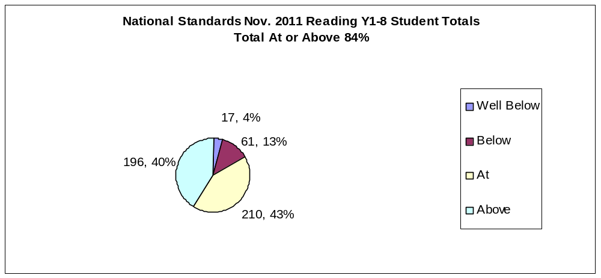
Total Number of Students - Reading
Well Below | 17
Below | 61
At | 210
Above | 196

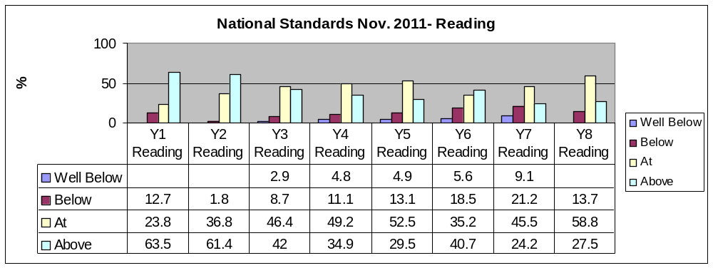

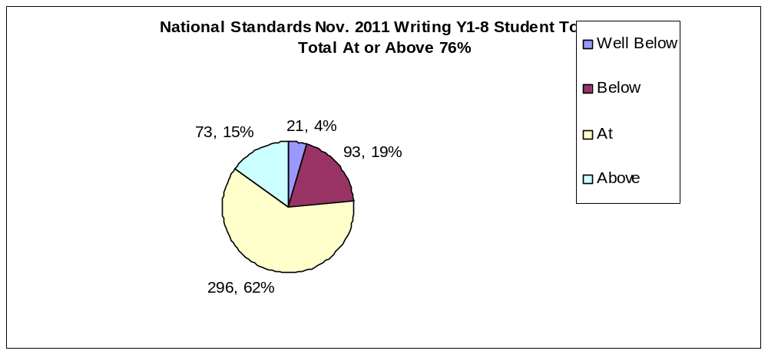
Total Number Of Students - Writing
Well Below | 21
Below | 93
At | 296
Above | 73
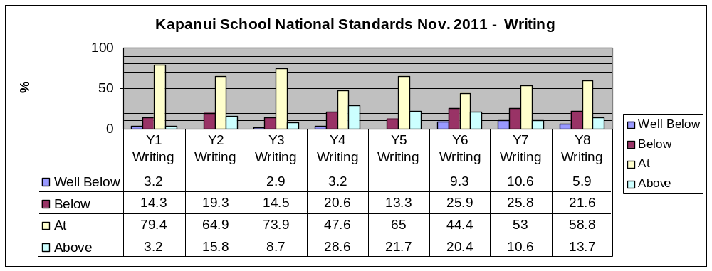

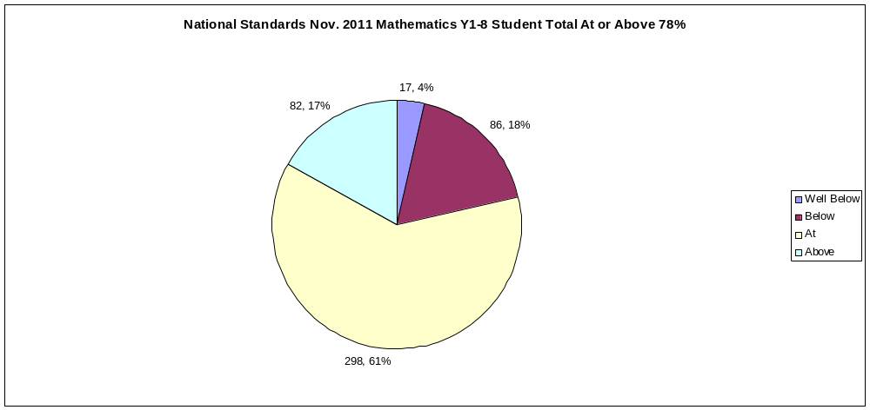
Total Number of Students
Well Below | 17
Below | 86
At | 298
Above | 82

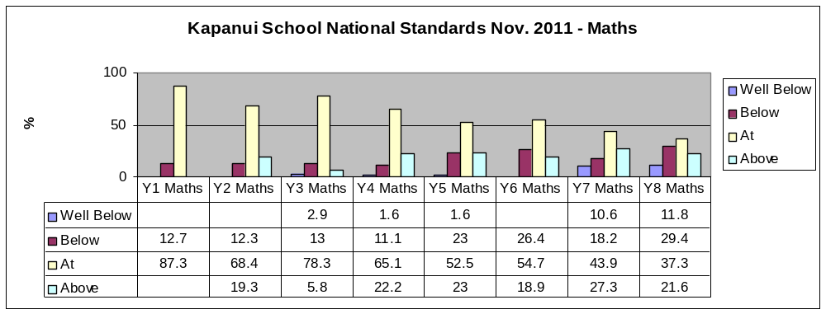
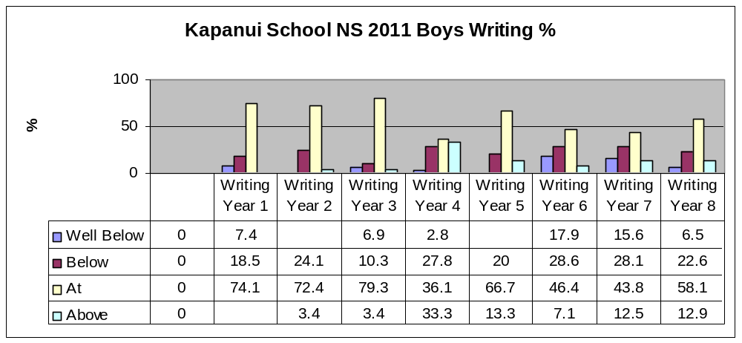
Male Writing Total At or Above 71.8%
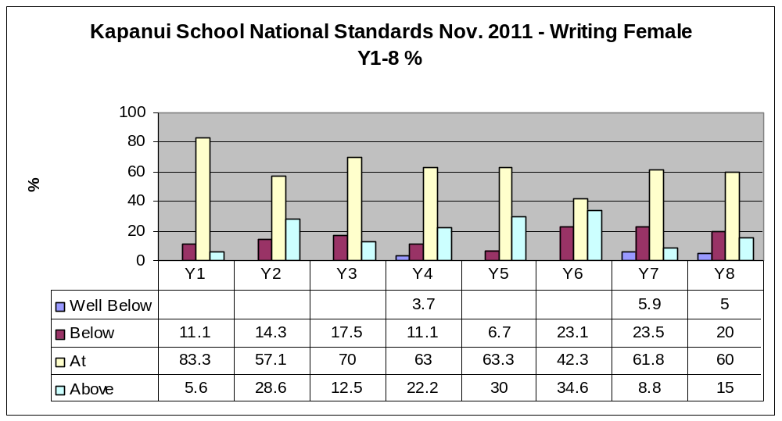
Female Writing Total At or Above 86.2%
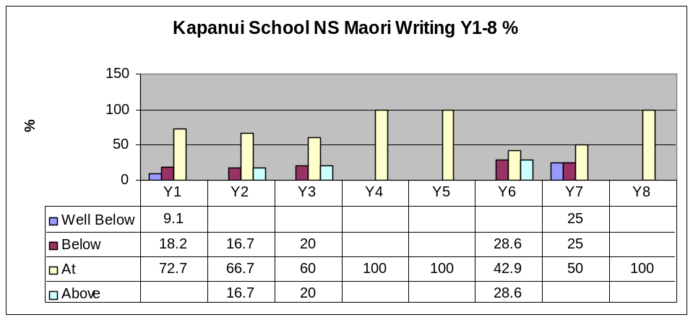
Maori Total Writing At or Above 82.1% Female Total Reading At or Above 87.5%
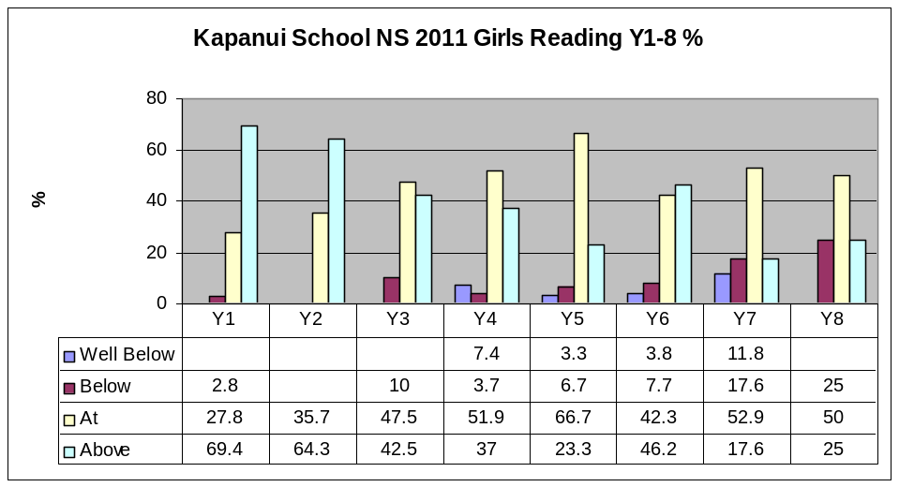
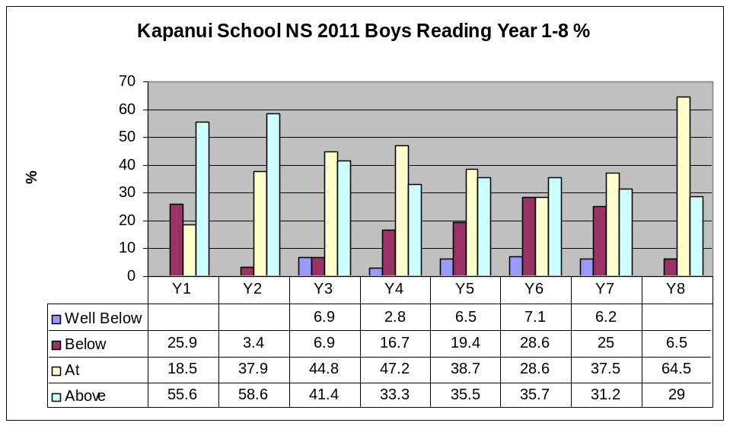
Male Reading Total At or Above 79.7% Maori Reading Total At or Above 76.8%
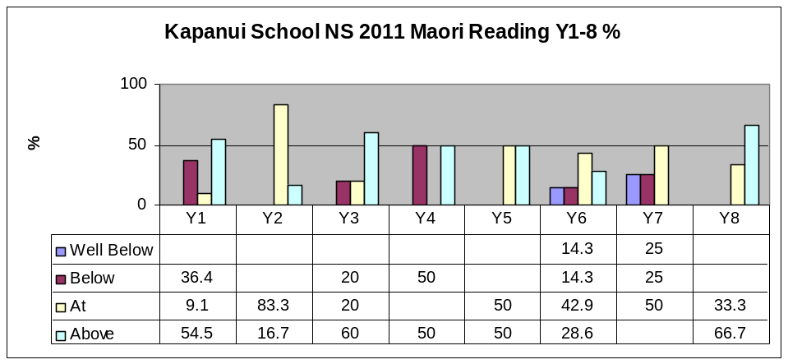

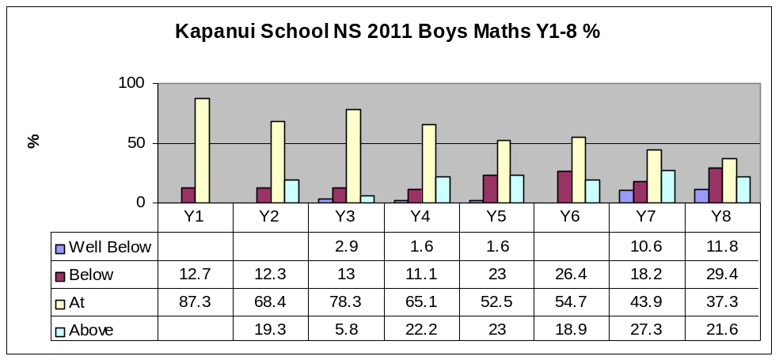
Male Maths Total At or Above 78.2%
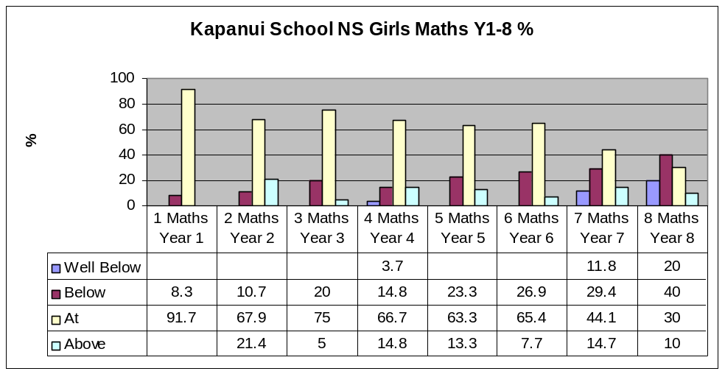
Female Maths Total At or Above 73.8%

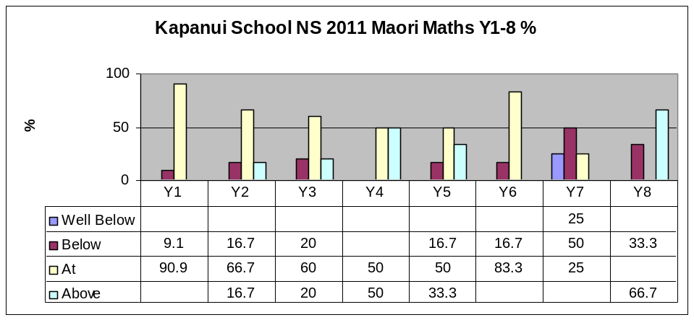
Maori Total At or Above 76.5%

Specific Target Groups – 2011 - Y1-4

Strategic Goal – Kapanui Students will achieve at or above expected levels for their age – Writing / Spelling / Reading / Numeracy
Comment -
Kapanui vision statements clearly highlight the foundation skills of literacy and numeracy as vital for our students to develop – “That all students not only need to achieve high levels of competency in literacy and numeracy but to take advantage of this they need to develop the “key competencies’. That each underpins the other and together these are the ‘foundations’ of learning.”
Kapanui School also states that it will operate an early identification / intervention policy for children at risk of not achieving.
Analysis of six year reading levels 2002 – 2007 indicated a general downward trend of students achieving at or above expected reading levels at 6. Reading was therefore targeted in a five year plan (2008 – 12) to lift the performance of reading at Kapanui School.

Target Group 1 – all students turning 6 in 2011
Focus Area – Reading | Gender - both | Ethnicity - all | Year Groups – Y1 and Y2

Historical Position | Achievement Target 2011 | Current Position Dec 2010 | Position Dec 2011 | Recommendations 2012
Analysis of six year reading levels 2002 – 2007 indicated a general downward trend of students achieving at or above expected reading levels at 6. See chart below. A 3 year programme to raise student achievement levels was developed 2009-11 | To achieve 90% of children turning 6 in 2011 at or above expectation as measured by the six year reading level. (Green – L12 +) | Below – Red Yellow Blue 15%  At –Green 12%  Above – Orange + 73%  At or Above 85% | Below – Red Yellow Blue 10%  At –Green 30%  Above – Orange + 60%  At or Above 90%  Target achieved | Continue with targeted group programme as per below and literacy focus for professional learning communities PLC’s.  Implement recommendations as per 2011 Special Needs report.

Target Group 2 – students identified as a risk of not achieving in reading through 5 year testing 2010
Focus Area – Reading |  |  | Gender - both |  |  | Ethnicity - all | Year Groups – Y1
Historical Position | Achievement Target 2011 |  |  | Current Position Feb 2011 - See list A | 2011 Dec - Analysis Average % at Green + |  |  | Recommendations 2012
In 2009 24% and 2010 15% of students turning 6 were below the target level of Green – L12. | To achieve 90% of identified target students at or above expectation (Green – L12) as measured by the six year reading level. |  |  | 18 students identified at a risk | Target not achieved  22% 4 students were below level 12. (2 Maori / 1 ESOL / 1 special needs)  78% 14 students were Level 12+ |  |  | All students to be monitored in 2013. The 4 students below the target to receive additional interventions in 2013. Parents to be included in intervention plans
2011 - Target Group 3 – students identified as a risk of not achieving in reading after 1 year at school through 6 year testing 2010
Focus Area – Reading |  |  | Gender - both |  |  | Ethnicity - all | Year Groups – Y1
Historical Position |  | Achievement Target 2011 |  | Current Position Feb 2011 - See list B | 2011 Dec - Analysis Average % at Turquoise |  |  | Recommendations 2012
In 2009, 24% and 2010, 15% of students turning 6 were below the target level of Green – L12. |  | To achieve 90% of identified target students at or above Turquoise – L17 as measured by the Nov reading level after 2 years at school |  | 26 students identified as a risk - includes students currently at expectation but progress causes concern | Target achieved  26 students achieved level17+ 100% |  |  | All students continue to be monitored in 2013
Target Group 4 – students identified as a risk of not achieving in reading through testing after 2 years at school 2010
Focus Area – Reading |  |  | Gender - both |  |  | Ethnicity - all | Year Groups – Y1
Historical Position |  | Achievement Target 2011 |  | Current Position Feb 2011 - See list C | 2011 Dec - Analysis Average % at Gold |  |  | Recommendations 2012
In 2010 it was identified that 13 (18%) students turning 7 were below the target level of Turquoise – L17. |  | To achieve 90% of identified target students at or above Gold – L21 as measured by the Nov reading level by the end of 3 years at school |  | 16 students identified as a risk (includes all ex RR students who require ongoing monitoring.) | Target achieved  6% 1 student was below level 21  94% 15 students achieved L21+ |  |  | All students to be monitored in 2013. The student below the target to receive additional interventions in 2013. Parents to be included in intervention plans

Planned Actions to Achieve Targets – Reading / Writing | Led By | Budget | Timeframe | completed
Review assessment data with staff to identify target students and determine their particular learning needs | Principal / Literacy Leader |  | T1 | 
Work with parents, families and whānau around ways to support students’ learning, particularly to inform choice of reading topics and materials | Literacy Leader |  | T1,3 | 
Process put in place for teachers to reflect on and improve practice – PLC’s | Principal / Literacy Leader |  | T1 | 
Four weekly monitoring meetings to discuss progress of target students – PLC’s | Literacy Leader |  | Ongoing | 
The progress of identified students will be assessed and reviewed at the end of each term and reported to the principal. | Literacy Leader / SENCO |  | Each term | 
A programme of professional develop focused on literacy teaching in years 1 -4 will be developed and implemented including opportunities for peer observations | Principal / Literacy Leader |  | T1,2,3 | 
All Y1 and 2 students and Y3-4 students at risk will have their progress tracked using wedge graphs. | Literacy Leader |  | Ongoing | 
All Y1 and identified Y2, Y3 and 4 students will take part in the PMP programme (perceptual motor programme). | SENCO | $3000 | Ongoing | 
Student voice considered in reading / writing topics and materials | TEAM Leader / Librarian | English $12000 / Library $15000 | T2 | 
6 places will be available in Reading Recovery | Principal / BOT | 0.6 staffing | T1 | 
Discontinued Reading Recovery students’ achievement will be monitored and remedial  actions taken where necessary | Reading Recovery Teacher |  | Ongoing | 
Tuakana Teina programme - Class buddies will be trained and encouraged to work with target students for regular reading | TEAM Leaders |  | T2,3 | 
Identify and provide TA support to students and teachers - 1-1 literacy support programmes- phonemic awareness, oral language, play groups | Principal / SENCO |  | T1 Ongoing | 
Moderation process developed and school based exemplars provided for students | Principal / TEAM Leaders |  |  | 2012
Analyse and reflect on year-end data to inform progress and planning for the following year | Principal / TEAM Leaders |  | T4 | 

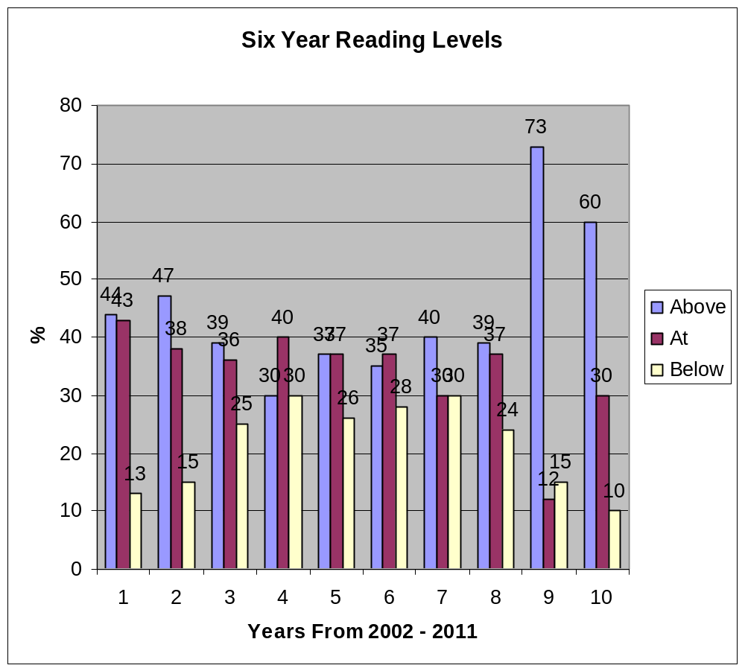
Data 2002 – 2009
Above – Turquoise and above – Level 17 and above
At – Blue – Orange – Level 9 - 16
Below – Yellow and below – Level 8 and below

Data 2010 / 2011 reflects the National Standard expectation of At being Green.

List A - students identified as a risk of not achieving in reading through 5 year testing 2010 – target L12

Year | Ethnicity | Gender | Level  T 1, 2011 | Level end T2, 2011 | Diff | Level end T3, 2011 | Diff | Level T4, 2011 | Diff year
1 | Other European | Male | 0 | 3 | 3 | 2/3 | 0 | 5 | 5
1 | NZ European/Pakeha | Male | 4 | 10 | 6 | 15 | 5 | 15 | 11
1 | NZ European/Pakeha | Female | 4 | 6 | 2 | 15 | 9 | 16 | 12
2 | Samoan | Female | 4 | 18 | 14 | 20 | 2 | 20 | 16
1 | NZ European/Pakeha | Female | 4 | 13 | 9 | 18 | 5 | 20 | 16
1 | NZ European/Pakeha | Male | 0 | 6 | 6 | 17 | 11 | 18 | 18
1 | Maori | Male | 1 | 5 | 4 | 6 | 1 | 5 | 4
1 | Maori | Male | 8 | 11 | 3 | 17 | 6 | 18 | 10
1 | NZ European/Pakeha | Male | 0 | 8 | 8 | 17 | 9 | 18 | 18
1 | NZ European/Pakeha | Female | 4 | 9 | 5 | 12 | 3 | 17 | 13
1 | NZ European/Pakeha | Female | 2 | 8 | 6 | 15 | 7 | 17 | 15
1 | NZ European/Pakeha | Female | 4 | A |  | 17 | 13 | 18 | 14
1 | NZ European/Pakeha | Male | 0 | 2 | 2 | 3\4 | 1 | 5 | 5
1 | NZ European/Pakeha | Female | 0 | 10 | 10 | 13 | 3 | 15 | 15
1 | Maori | Male | 1 | 9 | 8 | 15 | 6 | 16 | 15
2 | Maori | Female | 8 | 21 | 13 | 21+ | 0 | 20 | 12
1 | NZ European/Pakeha | Female | 0 | 8 | 8 | 11 | 3 | 16 | 16
1 | Maori | Male | 1 | 5 | 4 | 8 | 3 | 9 | 8

2010 - Total 20 / Maori 3 15% (School 10%) / Male 12 60%/ Female 8 40%
2011 - Total 18 / Maori 5 27.7% (School 10.2%) / Male 9 50%/ Female 9 50%

List B – students identified as a risk of not achieving in reading through 6 year testing 2010 target L17 (includes ex Reading Recovery students for monitoring)
Year | Ethnicity | Gender | Level  T 1, 2010 | Level T2, 2011 | Diff | Level T3, 2011 | Diff | Level T4, 2011 | Diff year
2 | NZ European/Pakeha | Female | 16 | 20 | 4 | 21 | 1 | 21 | 5
2 | NZ European/Pakeha | Male | 16 | 19 | 3 | 21 | 2 | 20 | 4
2 | NZ European/Pakeha | Male | 11 | 18 | 7 | 19 | 1 | 20 | 9
2 | NZ European/Pakeha | Male | 14 | 17 | 3 | 20 | 3 | 21 | 7
3 | NZ European/Pakeha | Female | 18 | 22 | 4 | 21+ |  | 22 | 4
2 | Other European | Male | 15 | A |  | 21 | 6 | 20 | 5
3 | Other European | Female | 18 | 20 | 2 | 21+ |  | 22 | 2
2 | NZ European/Pakeha | Female | 16 | 20 | 4 | 21 | 1 | 21 | 5
2 | NZ European/Pakeha | Male | 15 | 19 | 4 | 20 | 1 | 20 | 5
2 | NZ European/Pakeha | Male | 16 | 19 | 3 | 21 | 2 | 20 | 4
2 | NZ European/Pakeha | Male | 18 | 19 | 1 | 20 | 1 | 20 | 2
2 | NZ European/Pakeha | Male | 11 | 17 | 6 | 19 | 2 | 19 | 8
2 | Other European | Female | 11 | 15 | 4 | 17 | 2 | 20 | 9
2 | NZ European/Pakeha | Male | 16 | 19 | 3 | 20 | 1 | 20 | 4
2 | NZ European/Pakeha | Male | 8 | 16 | 8 | 17 | 1 | 18 | 10
2 | Filipino | Female | 8 | 17 | 9 | 20 | 3 | 20 | 12
3 | NZ European/Pakeha | Female | 18 | 20 | 2 | 20 | 0 | 18 | 0
2 | Other Asian | Male | 15 | 21 | 6 | 21+ |  | 23 | 8
2 | Other European | Female | 11 | 19 | 8 | 20 | 1 | 20 | 9
2 | NZ European/Pakeha | Female | 17 | 19 | 2 | 20 | 1 | 20 | 3
2 | NZ European/Pakeha | Female | 17 | 22 | 5 | 21+ |  | 23 | 6
3 | NZ European/Pakeha | Female | 16 | 20 | 4 | 20\21 | 0 | 20 | 4
2 | Maori | Male | 11 | 19 | 8 | 19 | 0 | 20 | 9
2 | Maori | Male | 6 | 15 | 9 | 19 | 4 | 20 | 14

2010 - Total 20 / Maori 3 15% (School 10%) / Male 11 55% / Female 9 45%
2011 - Total 24 / Maori 2, 8.6% (School 10.2%) / Male 13 54% / Female 11 46%

List C - students identified as a risk of not achieving in reading through testing after 2years at school 2010 – Target L21 (includes ex Reading Recovery students for monitoring)
Year | Ethnicity | Gender | Level  T 1, 2010 | Level end T2, 2011 | Diff | Level end T3, 2011 | Diff | Level T4, 2011 | Diff year
4 | Other European | Male | 19 | 19 | 0 | 20 | 1 | 20 | 1
3 | NZ European/Pakeha | Male | 18 |  |  | 20 | 2 | 23 | 5
4 | NZ European/Pakeha | Male | 23 | 23 | 0 | 23 | 0 | 23 | 0
4 | NZ European/Pakeha | Male | 24 | 24 | 0 | 24 | 0 | 25 | 1
4 | NZ European/Pakeha | Male | 22 | 24 | 2 | 24 | 0 | 23 | 1
4 | NZ European/Pakeha | Female |  | 21 |  | 22 | 1 | 22 | 1
4 | NZ European/Pakeha | Female | 22 | 23 | 1 | 23 | 0 | 23 | 1
3 | Maori | Female | 20 | 20 | 0 | 20 | 0 | 20 | 0
3 | NZ European/Pakeha | Male | 14 | 17 | 3 | 15 | -2 | 16 | 2
4 | Other | Female | 23 | 22 | -1 | 23 | 1 | 23 | 0
4 | Other European | Male | 25 | 26 | 1 | 26 | 0 | 26 | 1
4 | NZ European/Pakeha | Male | 20 | 21 | 1 | 23 | 2 | 20 | 0
3 | NZ European/Pakeha | Male | 18 | 17 | -1 | 20 | 3 | 20 | 2
3 | NZ European/Pakeha | Female | 19 | 21 | 2 | 20 | -1 | 23 | 4
3 | NZ European/Pakeha | Female | 19 | 21 | 2 | 23 | 2 | 23 | 4
3 | NZ European/Pakeha | Male | 20 | 24 | 4 | 23 | -1 | 23 | 3
2010 - Total 29 / Maori 3, 10% (School 10%) / Male 20, 69% / Female 9, 31%
2011 - Total 16 / Maori 1, 6.6% (School 10.2%) / Male 10, 62.5% / Female 6, 37.5%

Annual Student Achievement Target – 2011 – Y5 - 6
Strategic Goal – Kapanui Students will achieve at or above expected levels for their age – Writing / Spelling / Reading / Numeracy
Comment -
Kapanui vision statements clearly highlight the foundation skills of literacy and numeracy as vital for our students to develop – “That all students not only need to achieve high levels of competency in literacy and numeracy but to take advantage of this they need to develop the “key competencies’. That each underpins the other and together these are the ‘foundations’ of learning.”
Analysis of T4 2009 and 2010 school-wide numeracy data identified concerns in the achievement of a significant group of students in Y5-8. Teacher feedback indicated these students were performing at numeracy stages of concern or at risk. 2010 National Standard data for the total cohorts also showed only 68% of Y6, 50% of Y7 and 49% of Y8 students achieved At or Above. The data also indicated that the girls in Y5-8 were an at risk group as results were lower than for boys. 65% of Y7 and 45% Y6 girls were below or well below.

Target Group 5 – students in Y5 -6
Focus Area – Knowledge, Recall Basic Facts |  | Gender - both |  |  | Ethnicity - all | Year Groups – Year 5 and 6
Historical Position | Achievement Target 2011 |  | Current Position Feb 2011 | Position Dec 2011 |  |  | Recommendations 2012
Testing using the Banks test  At Risk  - All students at stage 3  - Year 6,7,8 students at Stage 4  - Year 8 students at Stage 5  Of Concern  - Year 6 students at Stage 5  - Year 5 students at Stage 4 | To reduce students considered at risk or of concern to 4 |  | 21 Year 5 or 6 students – 17.3% (21/121) considered to be at risk or of concern based on end of year expectations | Target achieved  2 Y5/6 students - 1.6% (2/121) considered to be at risk or of concern based on end of year expectations |  |  | Continue to identify students at risk or of concern, target and monitor progress, continue to involve parents,

At Risk | Concern | At Expectation | Above Expectation

Specific Target Group – 5 – Y5
Year | Ethnicity | Gender | Level  T1, 2011 | Level end T2, 2011 | Level end T3, 2011 | Level end T4, 2011
5 | Maori | Female | 4 | 7 | 7 | 7
5 | NZ European/Pakeha | Male | 4 | 5 |  | 5
6 | NZ European/Pakeha | Male | 3 | 6 |  | 6
5 | NZ European/Pakeha | Male | 2 | 4 |  | 3
5 | NZ European/Pakeha | Male | 2 | 5 | 5 | 5
5 | NZ European/Pakeha | Female | 4 | 5 | 5 | 5
5 | Maori | Female | 4 | 5 | 6 | 6
5 | NZ European/Pakeha | Male | 3 | 5 | 6 | 6
4 | NZ European/Pakeha | Male | 4 | 6 | 6 | 6

Specific Target Group – 5- Y6
Year |  | Ethnicity |  | Gender | Level  T1, 2011 | Level end  T2, 2011 | Level end  T3, 2011 | Level end  T4, 2011
6 | NZ European/Pakeha |  | Male |  | 4 | 6 | 5 | 5
6 | NZ European/Pakeha |  | Female |  | 4 | 7
6 | NZ European/Pakeha |  | Male |  | 5 | 6 | 6 | 6
6 | NZ European/Pakeha |  | Male |  | 5 | 5 |  | 6
6 | NZ European/Pakeha |  | Female |  | 4 | 6 | 6 | 6
6 | NZ European/Pakeha |  | Female |  | 5 | 6 | 6 | 6
6 | NZ European/Pakeha |  | Female |  | 5 | 5 | 6 | 6
6 | NZ European/Pakeha |  | Male |  | 5 | 7 | 7 | 7
6 | NZ European/Pakeha |  | Female |  | 5 | 5 | 7 | 7
6 | Other European |  | Male |  | 5 | 7 | 7 | 7
6 | NZ European/Pakeha |  | Female |  | 4 | 5 |  | 6
6 | Samoan |  | Male |  | 5 | 6 | 6 | 6
6 | NZ European/Pakeha |  | Male |  | 5 | 6 |  | 7
6 | NZ European/Pakeha |  | Female |  | 7 | 7 | 7 | 7
6 | NZ European/Pakeha |  | Female |  | 5 | 6 | 7 | 7

2010 - 36 Y5/6 students
2011 - 18 Y5/6 students
Annual Student Achievement Target – 2011 – Y7-8
Strategic Goal – Kapanui Students will achieve at or above expected levels for their age – Writing / Spelling / Reading / Numeracy
Defining the Goal-
Kapanui vision statements clearly highlight the foundation skills of literacy and numeracy as vital for our students to develop – “That all students not only need to achieve high levels of competency in literacy and numeracy but to take advantage of this they need to develop the “key competencies’. That each underpins the other and together these are the ‘foundations’ of learning.” Teacher feedback indicated these students were performing at numeracy stages of concern or at risk. 2010 national standard data also showed only 685, 50% of Y7 and 49% of students achieved At or Above. This data also indicated that the girls in Y5-8 were an at risk group as results were lower than for boys.
Target Group 6 – students in Y7-8
Focus Area – Knowledge, Recall Basic Facts |  | Gender - both |  |  | Ethnicity - all | Year Groups – Y7 and Y8
Historical Position | Achievement Target 2011 |  | Current Position Feb 2011 | Position Dec 2011 |  |  | Recommendations 2012
Testing using the Banks test  At Risk  - Year 7 / 8 students at stage 3 or 4  - Year 8 students at stage 5  Of Concern  - Year 7 students at Stage 5  - Year 8 students at Stage 6 | To reduce students considered at risk or of concern to 4 |  | 31 Year 7 or 8 students – 23% (31/134) considered to be at risk or of concern based on end of year expectations | Target achieved  2 Y7/8 students – 1.5% (2/134) considered to be at risk or of concern based on end of year expectations |  |  | Continue to identify students at risk or of concern, target and monitor progress, continue to involve parents  Be aware of developing positive attitudes to maths for girls

Specific Target Group – 6 (Y7)

Year | Ethnicity | Gender | Level  T1, 2011 | Level end T2, 2011 | Level end T3, 2011 | Level end T4, 2011
7 | Maori | Female | 3 | 3 | 3 | 5
7 | Other European | Female | 4 | 6 | 7 | 7
7 | NZ European/Pakeha | Male | 5 | 5 | 6 | 6
7 | NZ European/Pakeha | Female | 5 | 6 | 6 | 7
7 | NZ European/Pakeha | Male | 5 | 7 | 7 | 7
7 | Other European | Female | 5 | 6 | 6 | 6

Specific Target group 6 (Y8)

Year | Ethnicity | Gender | Level  T1, 2011 | Level end T2, 2011 | Level end T3, 2011 | Level end T4, 2011
8 | NZ European/Pakeha | Female | 6 | 7 | 7 | 7
8 | NZ European/Pakeha | Female | 6 | 7 | 7 | 7
8 | NZ European/Pakeha | Female | 6 | 7 | 7 | 7
8 | NZ European/Pakeha | Male | 6 | 8 | 8 | 8
8 | NZ European/Pakeha | Female | 6 | 6 | 6 | 6
8 | Other European | Female | 6 | 6 | 7 | 7
8 | NZ European/Pakeha | Male | 6 | 7 | 7 | 7

Tally of Students at each stage using - Guidelines for ‘End of Year Expectations’

2011

 | RISK T1 | CONCERN T1 | End T2 | End T2 | At T2 | End T4 | End T4 | At T4
Year 4 | 0 | 1 | 0 | 0 | 1 | 0 | 0 | 1
Year 5 | 4 | 4 | 0 | 1 | 7 | 1 | 0 | 7
Year 6 | 4 | 11 | 0 | 1 | 14 | 0 | 1 | 14
Year 7 | 2 | 5 | 0 | 2 | 5 | 0 | 0 | 7
Year 8 | 0 | 7 | 0 | 2 | 5 | 0 | 1 | 6
Total | 10 | 28 | 0 | 6 | 32 | 1 | 2 | 35

Targets November 2011

 | AT RISK  TARGET | ACTUAL | OF CONCERN  TARGET | ACTUAL
Year 5 | 0 | 1 | 2 | 0
Year 6 | 0 | 0 | 2 | 1
Year 7 | 0 | 0 | 2 | 0
Year 8 | 0 | 0 | 2 | 1
Total | 0 | 1 | 8 | 2

Planned Actions to Achieve Targets – Mathematics | Led By | Budget | Timeframe | Completed
Review assessment data with staff and determine the particular learning needs of target students | Principal |  | T1 | 
Work with parents, families and whānau around ways to support students’ learning | Numeracy Leader |  | T1,3 | 
Process put in place for teachers to reflect on and improve practice – PLC’s | Numeracy Leader |  | T1 | 
Fortnightly monitoring meetings to discuss progress of target students – PLC’s | Numeracy Leader |  | Ongoing | 
The progress of identified students will be assessed and reviewed at the end of each term and reported to the principal. | Numeracy Leader / SENCO |  | Each term | 
A programme of professional develop focused on numeracy teaching in years 5-8 will be developed and implemented including opportunities for peer observations | Numeracy Leader |  | T1,2,3 | 
Student voice considered in the teaching of mathematics | Numeracy Leader |  | Ongoing | 2012
Identify and provide TA support to students and teachers | SENCO / Numeracy Leader |  | Ongoing | 
Use numeracy advisors to provide in-class / PLC support for Y5-8 teachers | Numeracy Leader |  | T2,3
Review the teaching of number in ability cross grouped classes | Numeracy Leader |  | T1 | 
Review of equipment and resources to effectively meet mathematics and statistics curriculum needs | Numeracy Leader |  | T2 | 
Establish a picture of and monitor girls’ attitudes to mathematics through surveys and/or interviews over the year | Numeracy Leader |  | Ongoing | 2012
Teachers should help students to strengthen their number sense through fluency with basic facts and through exploration and understanding of number properties. There should also be an emphasis on students discussing, explaining and justifying their mathematical ideas, understandings and use of processes | Y5-8 teachers |  | Ongoing | 
Additional emphasis should be given to developing students’ abilities to understand and calculate with simple fractions and decimals. | Y5-8 teachers |  | Ongoing | 
To further develop ideas learnt through easier and simpler tasks, teachers should help students to develop strategies for approaching and solving mathematical problems that require multi-step or complex tasks. | Y5-8 |  | Ongoing | 
Analyse year-end data to inform progress and planning for the following year | Principal / TEAM Leaders |  | T4 | 

AREAS OF STRENGTH AND AREAS FOR IMPROVEMENT

2011 Reading – National Standards
School Reading Total At or Above 84%
Male Reading Total At or Above 79.7%
Female Total Reading At or Above 87.5%
Maori Reading Total At or Above 76.8%
Totals of other ethnic groups including Pacific are too small to provide useful comparison information

Comments – Kapanui has a high overall percentage of students achieving at or above national standard expectations 83.9% and has improved this percentage by 3.5% from 2010 to 2011. Results indicate that girls score higher than boys. Information from the student voice surveys Me and My School indicated - 74% of boys agree or strongly agree that they enjoy reading, while 90% girls agree or strongly agree that they enjoy reading. This trend was also evident in other question results indicating girls at Kapanui are more positive about school. However in comparison to national norms Kapanui boys are more positive, while girls are similar to national norms. While both our boys and girls results are slightly above national norms it is still an area of concern that school is less positive for our boys.
Recommendations to develop boys’ interest in reading and positive attitudes to school are included in the 2012 annual plan. Results for Maori are lower than for non Maori this trend is also evident in the percentages of Maori students in targeted groups. Increasing staff and school skill with the teaching of Maori students will be addressed in 2012 through staff development on Ka Hikitia the MOE document on success for Maori.

Kapanui results at each level exceed the MOE indications. However results also indicate that the percentage of students achieving at the NS or above drops significantly at Y6. This trend is not apparent in Ministry information which indicated the following - after 1 year 50%, at the end of Y4 60%, at the end of Y8 60% (MOE, NZCER). This difference will need to be monitored as we build an ongoing picture of national standard reading results at Kapanui School in relation to national results.
As a school we also need to continue to develop staff skills in making reliable OTJ,s and systems of moderation.

2011 Written language– National Standards
School Writing Total At or Above 76%
Male Writing Total At or Above 71.8%
Female Writing Total At or Above 86.2%
Maori Total Writing At or Above 82.1%
Totals of other ethnic groups including Pacific are too small to provide useful comparison information

Comments –Kapanui has a high overall percentage of students achieving at or above national standard expectations 74.7%. However this result is lower than the results for reading. Therefore written language will become a focus for school improvement in 2012 – 13. Results also indicate that boys score significantly lower than girls. An inquiry into this discrepancy and recommendations to address this will be included in the school wide focus on improving the quality of written language in 2012.
Results indicate that the percentage of Kapanui students achieving at the NS or above drops significantly at Y5.
Ministry information indicates that many year 7 and 8 students are underachieving in writing. The national asTTle analysis of writing samples for 2001–2005 indicated that year 8 achievement was significantly below curriculum expectations, and the 2006 National Education Monitoring Project (NEMP) reported only a “modest improvement” in writing since 2002 for year 8 students.
However, analysis of data from the Literacy Professional Development Project (2004–2009) shows that student achievement in writing accelerated significantly when teachers adjusted and monitored the impact of their own practice as they engaged with professional development in literacy. It is possible, then, to accelerate students’ achievement in writing. The success of the PLC approach at Kapanui to raising reading achievement at Kapanui in 2009/11 provides a model for a focus on accelerating writing progress in Y1-8. Writing achievement and the teaching of written language will be the next focus in 2012. Following this second assessment we can begin to look at trends with the different year group cohorts, gender and ethnic variations to help set targets in 2012.
Individual students at the well below and below assessment will be matched against targeted student groups for 2012 to ensure appropriate support is in place to accelerate progress

2011 Mathematics – National Standards
School Maths Total At or Above 78%
Male Maths Total At or Above 78.2%
Female Maths Total At or Above 73.8%
Maori Total At or Above 76.5%
Totals of other ethnic groups including Pacific are too small to provide useful comparison information

Comments – Kapanui has a high overall percentage of students achieving at or above national standard expectations 78% and has improved this percentage by 5.7% from 2010 to 2011.Results indicate that the percentage of students achieving at the NS or above drops significantly at Y5. This would indicate that the NS level becomes more “aspirational” as the children progress through the year levels. Ministry information indicated the following - after 1 year 80%%, at the end of Y4 70%, at the end of Y8 35%. (MOE, NZCER). Kapanui results at each level exceed these MOE expectations.
Over all boys score higher results than girls and this is particularly evident in Y7 and 8. Inquiring into this will be included in 2012 recommendations.

Summary Comments T4, 2011

Mathematics

The PLC programme has been effective in addressing the needs of these targeted students. Teachers have been creative in the strategies they’ve used to promote progress. Teachers readily share ideas/concerns/ successes with colleagues and challenge each others thinking.
Teachers’ content knowledge has improved over time as to the concepts at each stage and the ways that we can successfully move children up to the next stage.
Parental involvement has been a vital component to the success of the Programme. The importance of the home school partnership was stressed at the Parents Meeting in term one and the most significant gains have been made with the students whose parents attended the meeting and continued to work with their children at home.
Peer support has been a successful strategy in promoting progress. Careful pairing plays an important role in determining the outcomes. When ‘tutors’ are aware of the common goals and ‘tutees’ are comfortable with the support then very good achievement has been noted
While the data shows significant progress, I think all teachers involved would agree that these children will continue to need close monitoring next year when the expectations will be raised according to their year level.
While some of the students are secure at the current level there are some whose results remain inconsistent
Data indicates that most progress is made within the first two terms. We need to consider what this means and how we can continue to make accelerated progress for these students.

Literacy – Reading

The PLC process and the use of targeted student groups have been very successful. Teachers report in feedback that they feel very positive about the processes and the outcomes both for them in relation to professional practice and development and to the outcomes for the students. Despite the extra time and meetings involved the teachers all indicate that the school should continue with this approach.

The introduction of more opportunities to observe colleagues was positive and is to be continued in 2012. During 2012 we will also introduce more outside expertise to the process. Written language will also become more of a focus in the meetings and students needing support with written language will be targeted.

Monitoring of students who have been in targeted groups in previous years indicates that for many of these students progress remains fragile and ongoing support is needed.

The special needs programmes available to the students of Kapanui School and the professional support and advice provided for the teaching staff and parents are of the highest quality. Of note in 2011 was an ESOL verification audit carried out by the Ministry Of Education. This report highlighted the high quality of the programme developed and delivered by the SENCO and her team.

Achievement information indicated that percent of students at or above expectations for reading after one year at school have steadily risen since the literacy interventions beginning in 2009 (70% at or above 2008 to 90% at or above 2011). This positive staff development has provided a successful model which in 2012 will be used to focus on raising the quality of written language at Kapanui School. All staff have contributed to this positive increase in reading levels and deserve credit for the extra work and effort involved.

Student engagement plays a major role in raising student achievement. Results from the student voice Y7 surveys Me and my School completed in T4, 2011 indicate that overall the Kapanui results are consistent with national norms for Y7 students. This places the majority of our Y7 students in the positive percentages for attitudes to school, with most responses in the 80% + for agreeing or strongly agreeing with the positive statements regarding school. The majority of our students are therefore positive about school and engaged students.

Kapanui School has positive responses in areas such as –

- School often feels like a waste of time to me – 86% disagree or strongly disagree
- I feel safe at school – 99% agree or strongly agree
- People care about each other in this school – 89% agree or strongly agree
- My family’s culture is treated with respect by the teachers – 100% agree or strongly agree
- I am comfortable talking to teachers at this school about problems – 79% agree or strongly agree
- There is just the right amount of challenge for me at this school – 90% agree or strongly agree
- I pay attention in class – 90% agree or strongly agree
- I find it easy to concentrate on what I am doing in class – 81% agree or strongly agree
- I take notice of the comments my teacher makes about my work – 91% - agree or strongly agree

WD Hedley
Principal

Recommendations 2012

- That the BOT continue to fund the PMP programme - $3000
- That the BOT provide a similar level of funding as in 2011 to top up ORRS, SEG and TEFA funding for special needs ($17000).
- That the BOT continue to fund where necessary any short fall in SENCO staffing up to 0.8. ($35000).
- That the school continues to provide up to 6 reading recovery places.
- That an emphasis on providing early identification and intervention of students at risk of not achieving in literacy and numeracy be maintained and reflected in TA programmes.
- That the school continue to identify students and set achievement targets based on the needs of identified students. Target groups to be identified from 2011 information and data.
- Continue to identify students at risk or of concern, target and monitor progress, continue to involve parents
- Be aware of developing positive attitudes to maths for girls
- That the school continues to develop the professional skills and knowledge of the staff through active PLC’s. That the PLC’s continue to de-privatise classrooms and teacher practice by providing -
  - a supportive forum for professional conversation
  - opportunities to observe and be observed
  - support for teachers to be reflective of their own practices and that this is to include shared reflection
  - staff development to enhance teacher inquiry
  - the use of outside expertise to supplement current staff expertise
- That the provision of programmes to meet the needs of identified GATE students continues to be a priority.
- Evidence indicates that Maori and boys account for a disproportional percent of the SN registers therefore the school should provide development as suggested in the Ministry document Ka Hikitia and staff development on raising engagement and achievement for boys.
- That support programmes for students Y3+ are developed and implemented in response to identified needs. In particular those students, who have been identified early, received early intervention but continue to achieve and progress well below expectations.
- That the school continue to develop partnerships with the parent community to support student achievement and progress.
- Research indicates that student engagement plays a significant role in student achievement and progress therefore the school should identify and develop programmes that enhance student engagement and in particular opportunities for “student voice”. As part of this the school should develop systems to evaluate student engagement.

