Mathematics - PAT (Progress and Achievement Test) – Term 1, 2010-04-28

PAT enables a student’s achievement to be compared against National Norms.

PAT Stanines and their associated test scores are scaled and normed to fit the Bell Curve of Normal Distribution.
National Standards
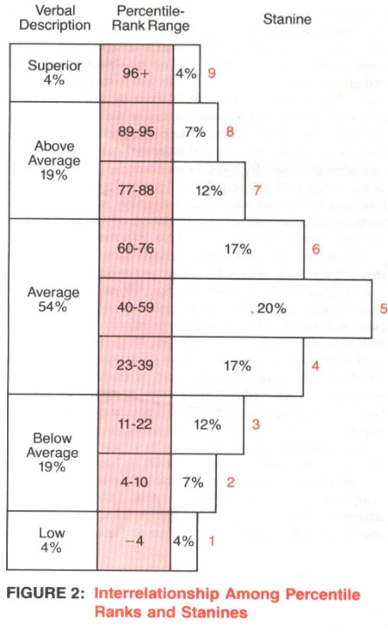
As a generalisation those students falling into…..
Stanine 1 can be described as performing ‘Well Below’ National Standards
Stanines 2, 3 can be described as performing ‘Below’ National Standards
Stanines 4, 5, 6 can be described as performing ‘At’ National Standards
Stanines 7, 8, 9 can be described as performing ‘Above’ National Standards

Mathematics PAT (Y3 to 8) - Number Knowledge, Number Strategies, Algebra, Geometry/Measurement and Statistics

Mathematics AsTTle - (Y3 to 8) – Number Knowledge, Number Strategies, Algebra

Overall performance
National Norms students at or above Stanine 4 =77%

Kapanui PAT Mathematics at or above Stanine 4
Y4 - 86% - +9
Y5 - 85%- +8
Y6 - 80%- +3
Y7 - 82%- +5
Y8 - 85%- +8

National Norms based on the percentage of students below or well below Stanine 1, 2, 3 (Norm =23%)

Kapanui PAT Mathematics percentage of students below or well below Stanine 1, 2, 3
Y4 - 14% - -9
Y5 - 16%- -7
Y6 - 20%- -3
Y7 - 18%- -5
Y8 - 15%- -8

Maori Performance
Below are the percentage results for Maori students at Kapanui. Because these are small numbers of students it is difficult to use these figures to make valid assumptions. However results do not appear to differ significantly from the data for all students.

National Norms students at or above Stanine 4 =77%

Kapanui PAT Mathematics Maori at or above Stanine 4
Y4 - 90% - +13 – total Maori 10 students
Y5 - 80%- +3 – total Maori 5 students
Y6 - 86%- +9 – total Maori 7 students
Y7 - 100%- +23 – total Maori 2 students
Y8 - 66%- - 11– total Maori 9 students

National Norms students below or well below Stanine 1, 2, 3 (Norm =23%)

Kapanui PAT Mathematics percentage of Maori students below or well below Stanine 1, 2, 3
Y4 - 10% - -13
Y5 - 20%- -3
Y6 - 14%- -9
Y7 - 0%- -23
Y8 - 33%- +10

Staff have used the PAT results to –
- Identify any year group areas of weakness – Item analysis of each year group indicates the following –
  - Y4 – solving problems using money, solving number problems in a word problem
  - Y5 – using 6 times table, using a number line, understanding reflection
  - Y6 - solving problems using money, solving number problems in a word problem, reading a scale
  - Y7 - solving number problems in a word problem, using pictograms
  - Y8 – understanding volume, rotation, average, decimals, tessellation
- Group students for teaching purposes both within home rooms and where appropriate across teams
- Identify students who need specific support within class programmes
- Identify students for the school achievement target groups
- Report to parents on student achievement levels in relation to NZ norms and areas of strength, weakness or gaps
- To cross check with asttle results

Attached below are the year group stanine distribution graphs for PAT Mathematics All students’ term 1, 2010.


